Sample of soil | What I saw happen when  vinegar was added to it

Crime scene

- Did all the soils you experimented with react the same with vinegar?

- Can you name any pupils who might be possible suspects? Explain why you chose them.

- Could any of the suspects have been telling the truth about where the soil on their trainers came from? Explain.

- Is it possible to prove who carried out the crime from your evidence?
Justify your answer!

Vinegar is a solution of acetic acid (also called ethanoic acid). It is a weak acid which means it can be used on food such as pickled beetroot and pickled gherkins without doing us much harm. The word ‘pickled’ is used to show the beetroot or gherkins have been preserved by soaking them in vinegar. Bacteria will cause food to rot. However, some bacteria cannot survive in acid solutions which have a low pH number. The vinegar stops them rotting because it is an acid with a low pH number.

Another weak acid is carbonic acid. It is made in the atmosphere when carbon dioxide gas dissolves in rain water. An equation for its formation is:

Carbon dioxide gas + Rain water Carbonic acid solution
Or
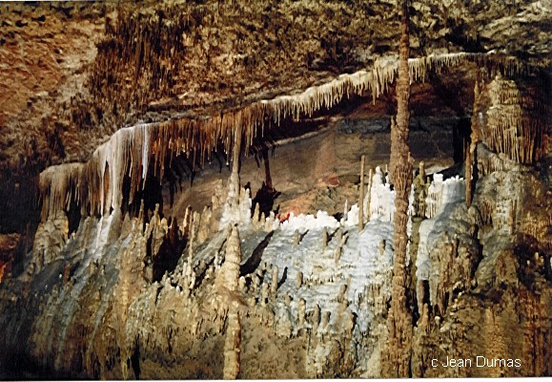
This carbonic acid solution falls as rain. You will have seen that some of the soil samples fizzed when they were mixed with vinegar. Some of the soil particles reacted with the vinegar and dissolved. In the same way, some types of rock can also react with carbonic acid in rain water. One type is called limestone. When the carbonic acid reacts with limestone, the limestone rock starts to dissolve. The calcium carbonate in the limestone reacts with carbonic acid to form calcium hydrogencarbonate, which is soluble. Over thousands and thousands of years the rain hollows out huge caves in the underground limestone rock.
The carbonic acid in the rain is
also responsible for the formation
of stalactites and stalagmites
in the caves. These are the rock
pillars which grow up from the
floors and down from the ceilings.
Stalagmites grow from the floor
and stalactites from the ceiling
(easy to remember which is which:
stalagmites grow from the ground
and stalactites grow from the ceiling). http://www.scsc.k12.ar.us/DumasJ/

As the calcium hydrogencarbonate solution drips from the ceiling of the cave, it evaporates and changes into solid calcite. Eventually this builds up into stacks growing down from the ceiling and up from the floor. When those growing up from the floor meet those growing down from the ceiling, they can form complete pillars.

