Video Analysis of Brownian Motion

Theory predicts that the mean squared displacement of Brownian Motion particles will be proportional to time.

Using a microscope connected to a laptop computer, a video showing the random movement of some microspheres suspended in liquid was taken.  We have previously described motion analysis using tracker.jar. The guide produced for that activity may be helpful here. The Brownian Motion video was imported into tracker. The software was used to find the X displacement of particles with time. It is important that a fixed time interval is used but the time interval chosen is arbitrary. We chose to find the displacement every 30 frames, approximately once every second.  Firstly, a particle to be tracked was identified and the axes moved so that the origin was over the point. |  |  | 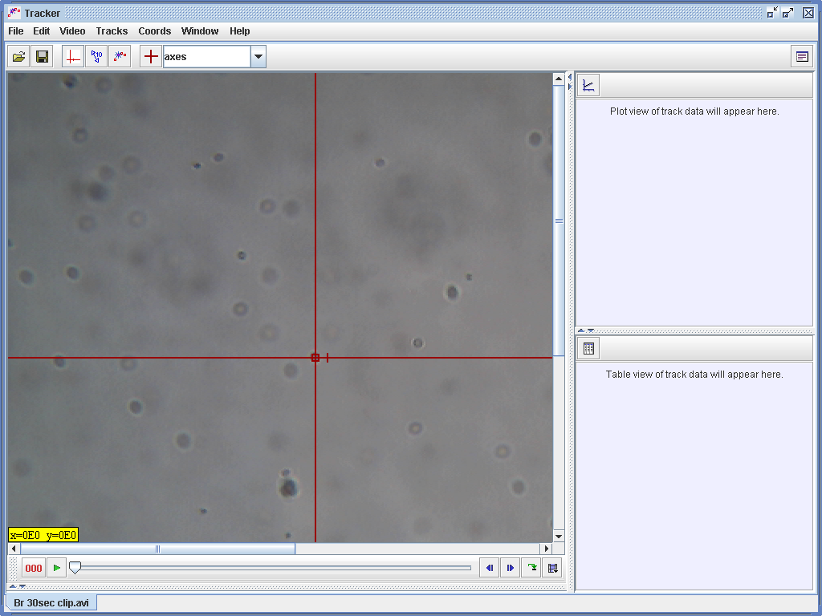
The axis button was then clicked again to make the axes invisible. If this is not done, it is hard to mark the position of a point that lies on an axis or at the origin. Clicking merely selects the axes again instead of marking the point.  The track control button was then used to create a new track. The slider and step forward controls were then used to move to frame 30. |  |   Slider

Step back / forward one frame


Frame counter showing frame 30

The centre of the chosen point was then shift-clicked. Its X and Y co-ordinates should then appear in the table on the right of the screen. |  | 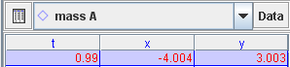  Co-ordinates entered in table automatically
The controls were then used to advance to frame 60 and the process was repeated. This could be problematic if the particle had not moved appreciably – it proved impossible to mark the position of the point unless the previous markers were made invisible. This was achieved by clicking on the mass A button (right) and unchecking Visible.  The particle was tracked every 30 frames from frame zero to frame 900. |  | 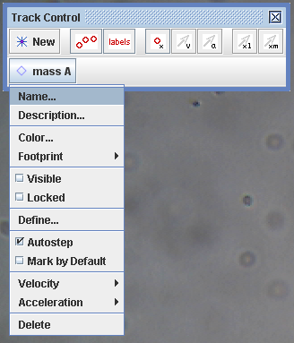
We were interested in motion in one dimension only. When all results were taken, we dragged down the column of X displacements, then right-clicked. |  | 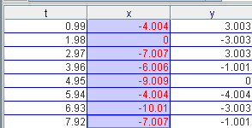
This brought up a menu, from which we selected Copy Data.  To process the data, an Excel spreadsheet was opened (without closing tracker down). |  | 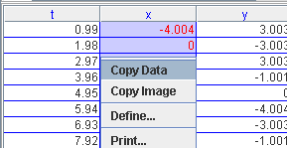
The data was pasted into the second column of the Excel spreadsheet, column 1 being reserved for time values that were to be entered later.  The entire process was repeated for another 9 particles. It became difficult to remember which particles had been previously chosen, because we deleted previous tracks before starting new ones. On reflection, this was a mistake.  It was important to remember to reset the axes for each point. |  | 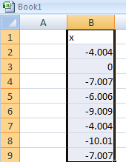
We added a time column (in seconds) to our spreadsheet and a column which, for each row, calculated the mean squared displacement. We then graphed mean squared displacement versus time. The results are shown below.
We aimed to show that mean squared displacement was proportional to time. We then tried to track another 10 particles to see if our results became closer to those predicted by the theory.  We believe our results may not be quite as expected because, on examining the video, there is an apparent net drift of the particles. | 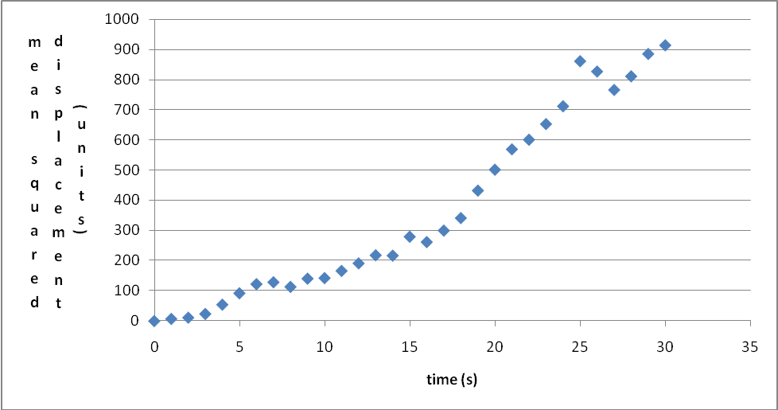
We believe that this activity could form part of an interesting Advanced Higher investigation into Brownian Motion.

