
Thionin

Materials: Chemical Changes SCN 3-19a
To sow a colour change in a chemical reaction

(For the chemistry courses, it can be used to show a colour change in a chemical reaction in Unit 1(ii) of the Intermediate 2 course, Unit 1(b) of the Access 3/Intermediate 1 course and in Unit 1 of the Standard Grade course. It can also be used when teaching oxidation/reduction and oxidising/reducing agents in Unit 3 e(i) of the Higher course, Unit 3 (ii) of the Intermediate 2 course and Unit 10 of the Standard Grade Course, not to mention being used generally to illustrate reversible chemical reactions.)

Background
We came across this reaction on an American site http://www.elmhurst.edu/~chm/demos/thionintwofacereac.html
It also appears as one of a number of interesting chemical demonstrations at http://www.flinnsci.com/Sections/Chemistry/chemDemonstratoins.asp

chemical reactions studied in schools usually involve the mixing of various chemicals or the application of heat. In this demonstration, it is not the addition of a new chemical, or heat, which starts the reaction. It is brought about by the introduction of a light source and is therefore called a photochemical reaction.

Thionin is an organic compound that can exist in two forms; a purple oxidized form and a colourless reduced form. When a reducing agent such as iron(II) (Fe²⁺) ions is added to an acidified thionin solution, light induces the reduction of the protonated thionin molecule (here simplified toThio⁺) to its colourless form by the Fe²⁺ ions. This is an example of the conversion of light energy to chemical energy.

The reaction can also be reversed. When the light source is removed, the purple colour, due to the oxidized form of thionin, returns. If part of the solution is shaded,
the solution on the side shaded from the light remains purple, while the side exposed to the light turns colourless. The boundary between the colourless and purple form is very sharp.

The reduction and oxidation equations are:

The equation showing the reversible reaction is:

What you will need
- Aluminum foil and white card taped together.
- 1litre glass beaker
- 2 g iron(II) sulphate, (FeSO₄.7H₂O) (Harmful)
- 100 cm³ 1M sulphuric acid solution (Irritant)
- 100 cm³ measuring cylinder
- 10cm³ of a solution of Thionin (Harmful)
- 500cm³ of distilled water
- Overhead projector.

What you do
Preparation of the thionin solution:
Dissolve 0.02 g of thionin in a little distilled water and make up the volume to 100 cm³
with more distilled water.

Just prior to the demonstration:
Mix the following chemicals together in a 1litre beaker -

10 cm³ of freshly prepared thionin solution, 100cm³ of 1 M sulphuric acid,
and sufficient distilled water to bring the final volume to about 500 cm³.

The demonstration:
Add the 2.0 g of iron(II) sulphate to the thionin mixture. Stir to dissolve.
Note the colour of the solution. Place the beaker on the overhead projector stage. Turn on the lamp. The solution will change from purple to colourless in a matter of seconds. Turn off the lamp and the purple colour will return. (A piece of white card behind the beaker is useful for viewing the colour change). You could also try turning the room lights off for the demonstration.

Try this!
Tape together a large sheet of white card or stiff paper (35 cm x 45 cm is ideal), andthree layers of aluminium foil, to form two layers.

Place a 1litre beaker on the card and draw round half its base.
Cut out a ‘D’ from the card/foil, using this mark as a template.
Fold the long side to give a white viewing screen 15 cm wide and place the
foil/card on the OHP (lamp switched off).

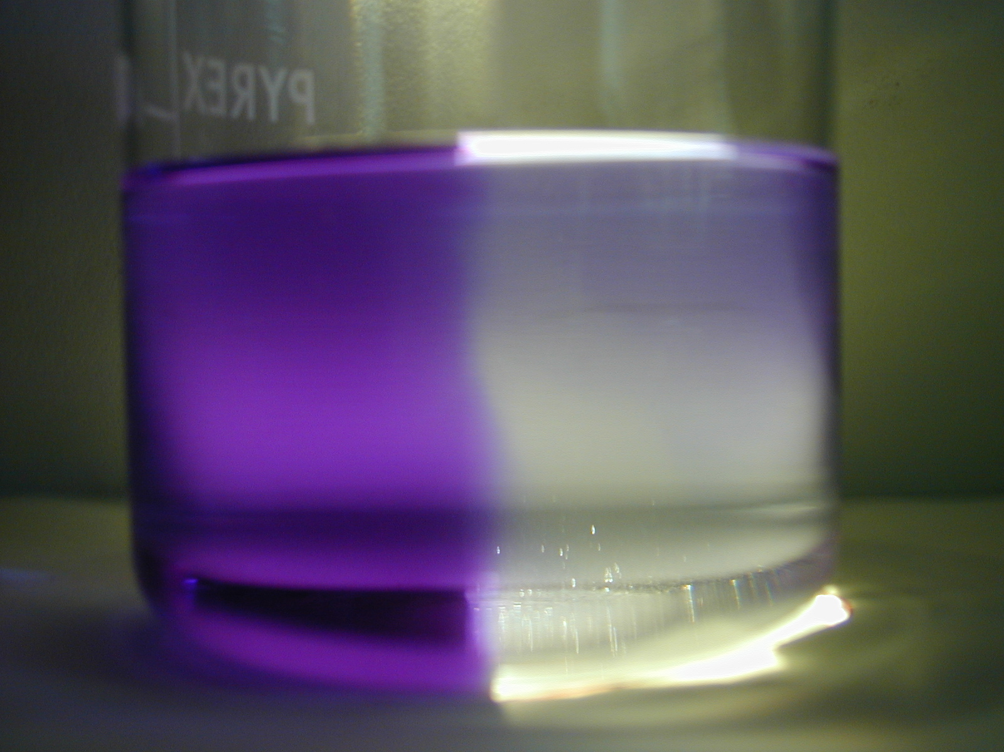
Place the beaker on the is in low light conditions until it appears purple, place the beaker on the projector stage so that half of the beaker is sitting over
the cut out ‘D’ of the card. Turn on the projector lamp
and observe the solution. A distinct vertical division
between the purple side and colourless side should be
clearly visible. (The vertical division indicates that
the reaction is initiated by light and not heat and is
best observed when the students are in direct line with it).
The reaction can be reversed by turning off the light and
is reversible for several days.

Tips
• Prepare the thionin solution fresh. It has a poor shelf life so is best used within one week. However, the thionin solution can be stored in a dark bottle and satisfactory results still obtained even after one month.
• The extent of any colour change will fade over time from bright purple to a paler shade of blue to purple. and the colour takes longer to return.

• Direct, bright sunlight may also be used as the light source.
- Thionin can be obtained from Sigma-Aldrich as thionin acetate (code T3387–5G)
at a cost of £24.50/5g
- Wear gloves at all stages of the preparation of the solution and the demonstration.

Safety
Wear eye protection. Wear gloves

It is the responsibility of teachers doing this demonstration to carry out an appropriate risk assessment.

