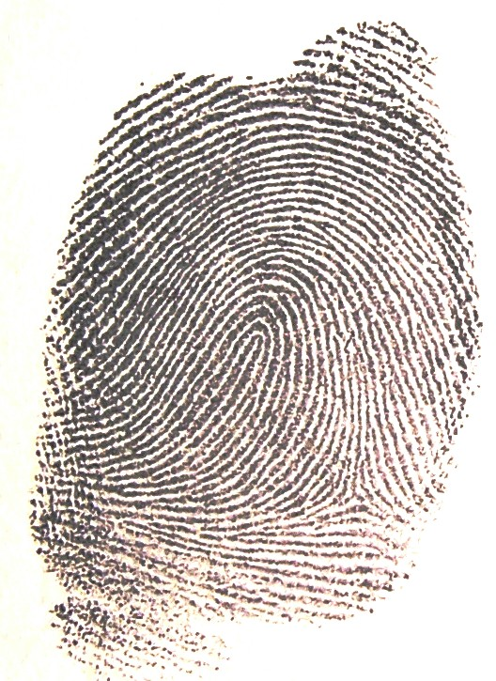
This is the fingerprint It is the type called
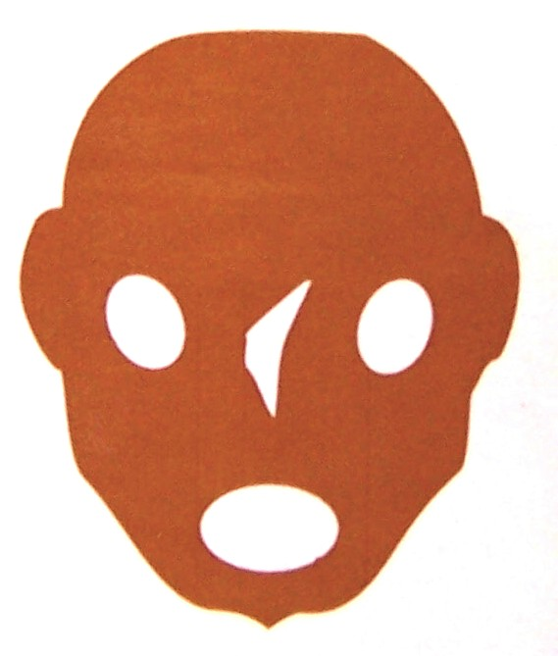
found on the CD

These are the fingerprints from the pupils:
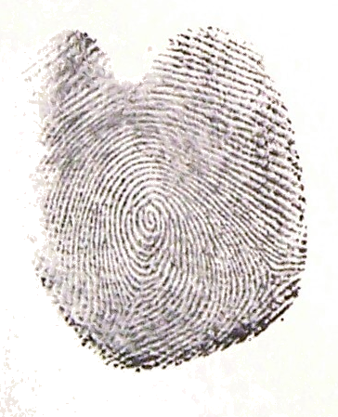


It is the type called

Claire
Smith

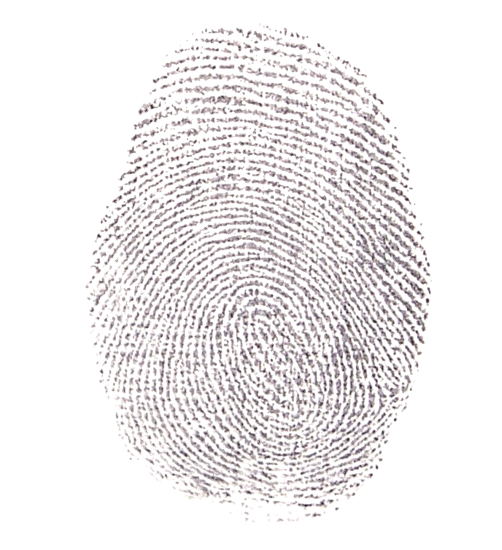

It is the type called

Dougal
Munro

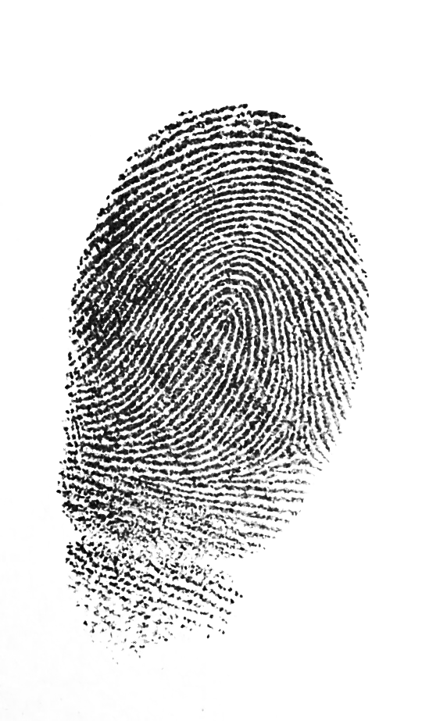

It is the type called

Jamie
Jenkins

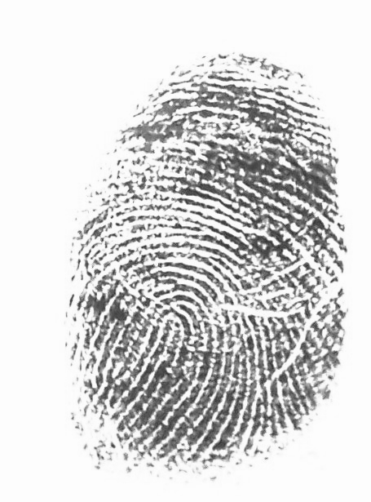


It is the type called

Wayne
Walker



Discuss the following points: Note down your thoughts on the sheet provided.

- Were any of the four suspects’ fingerprints a different type to the one found on the CD? If so, who were they?

- Does this mean these persons could be totally innocent?

- Did any of the suspects’ fingerprints match the type found on the CD?
If so, who could have left their fingerprint there?

- Were these prints identical? Is there enough evidence to definitely say
who had left their fingerprint on the CD?

- Does this prove who had committed the crime? Explain.

