Miss Taken was still hopping mad. Not only had her desk been emptied but the floor was all muddy. There was even what looked like a shoe print on the desk by the window and the flower bed outside the window was all churned up. She decided to photograph the footprint and to collect some of the soil from the floor before the cleaners came in. She had a feeling that might prove useful.

When the four suspects were questioned, all were wearing muddy trainers but denied they had been anywhere near her room.

Jenkins and Walker swore they were playing football in the football field together, but no one can remember seeing them.
Dougal Munro said the mud on his trainers was from his back garden while Claire Smith didn’t even know her trainers were muddy.

Miss Taken decided to photograph the trainers of the four pupils. She also decided to get some soil samples from the trainers,
She thought she might be able to do some test on the soils.
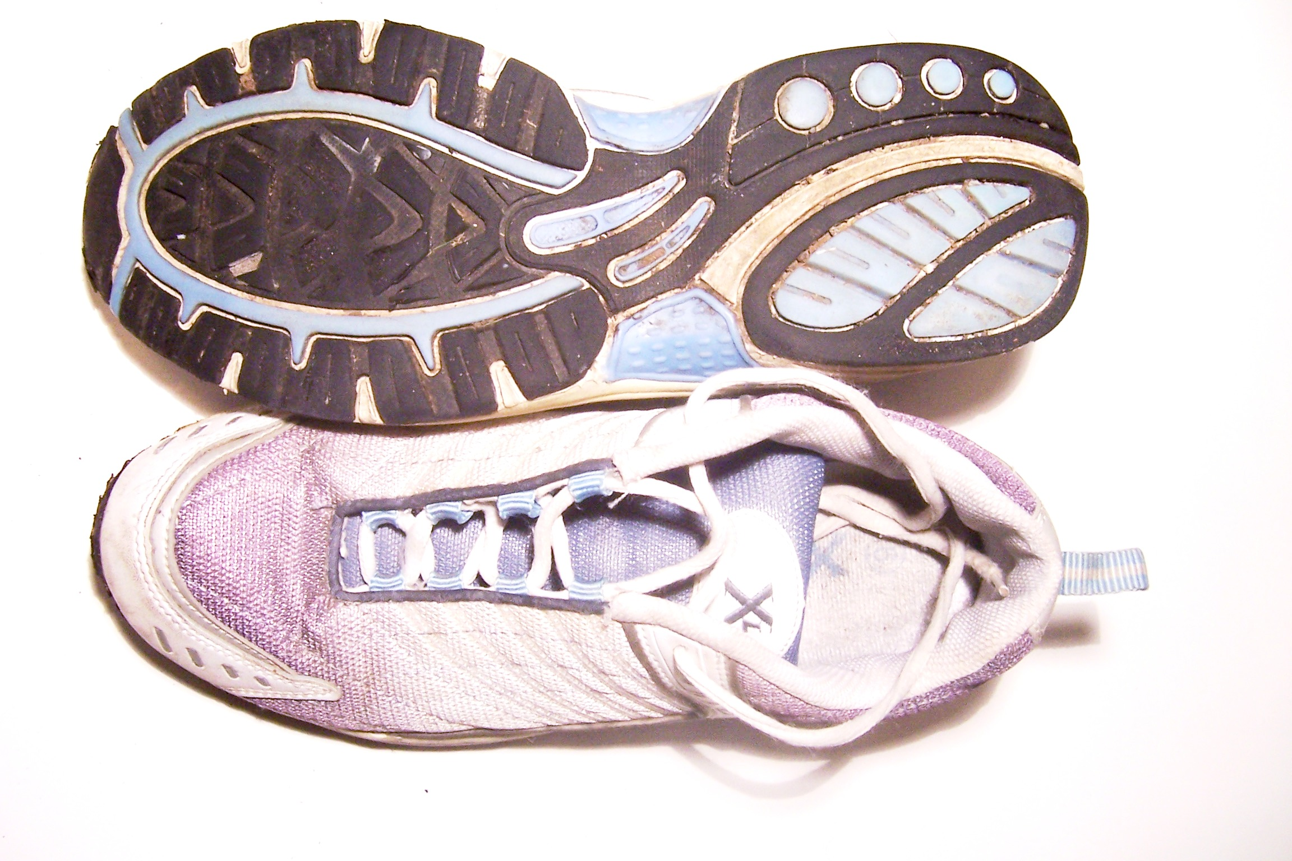

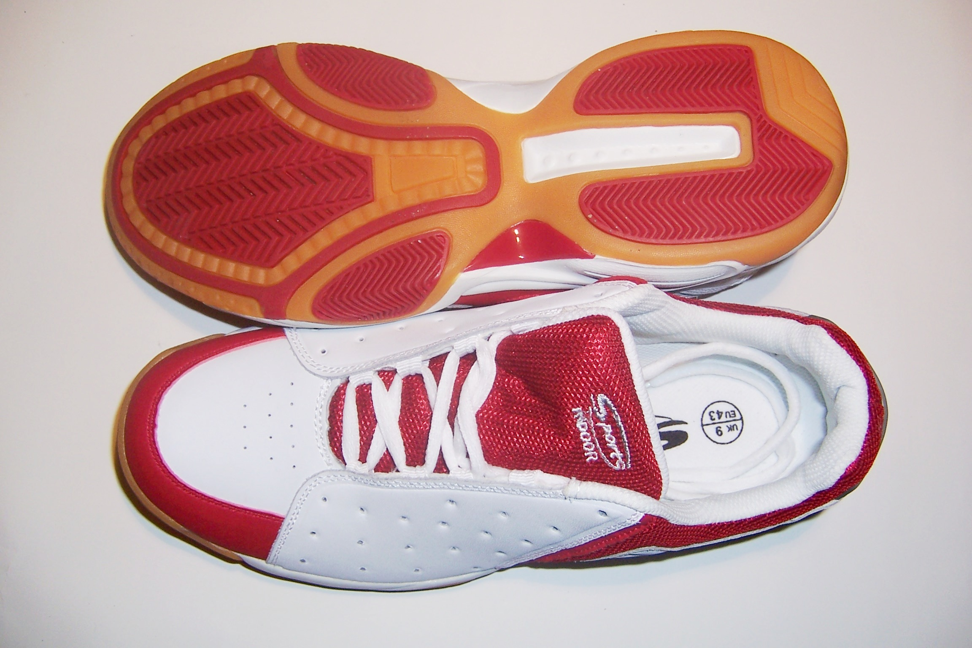
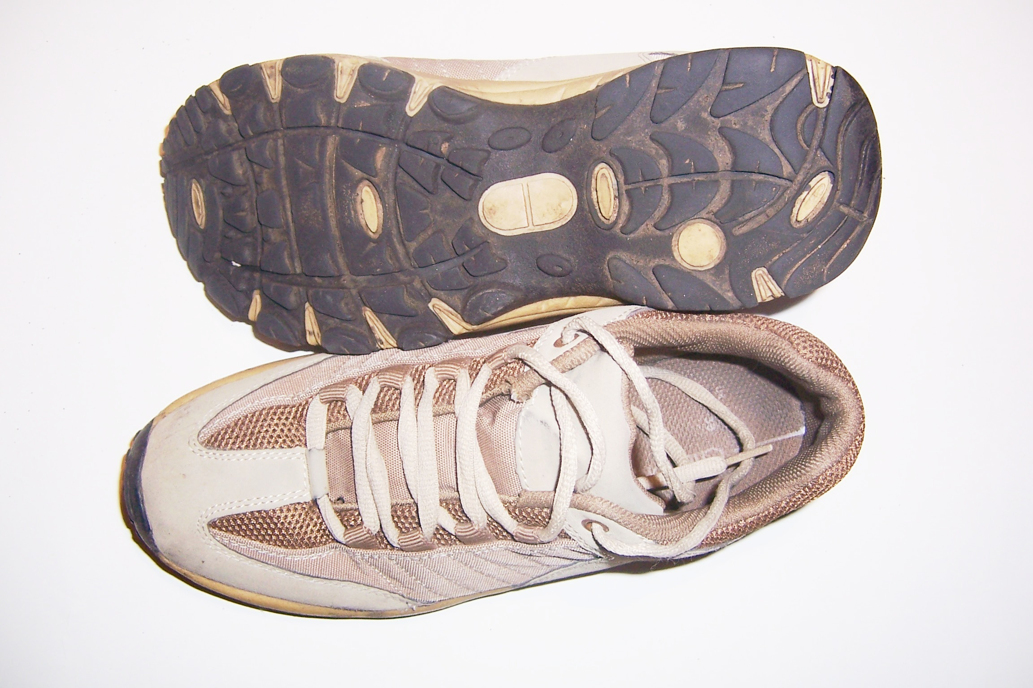

You are now going to be soil detectives to help Miss Taken work out if one of these pupils could have been the culprit.

- How could the photograph of the footprint help?

- How might testing soil samples help Miss Taken catch the culprit?

- Will you require any additional soil samples apart from the ones from the trainers and the floor?
Now Turn Over / ........

Miss Taken thought there were quite a few tests she could do on the soils. e.g.

- She could look at soil samples under a microscope to see if they were in any way different.

- She could add vinegar to them and watch what happened.

- She could add water to them, collect clear samples of the liquids from the soils, and then do some tests on the them such as:

- wetting a piece of pH paper with the liquid and see what happened

- blowing a fine mist of the liquid through a flame (a ‘flame test’).

- How could looking at soil under a microscope help?
What differences could you look for?

- What might you see happening if you added vinegar?

- How could you collect a clear sample of the liquid from the soil?

- What might you look for when you used pH paper?

- What might you look for when doing the ‘flame test’?

Now jot down some of your ideas on the Soil Analysis sheet

