A quick guide!

- Standard microscope

Steps
- Click smallest objective lens into place
- Look through eyepiece and adjust mirror to show clear circle of light
- Place slide on stage
- Lower objective lens until just above slide (using focus knob)
- Look through eyepiece and slowly turn focus knob until object on slide is clear
- Move X10 objective lens into place and adjust fine focus to give clear image
Eyepiece lens
Focus knob

Objective lens
Stage
Mirror

- Motic microscope
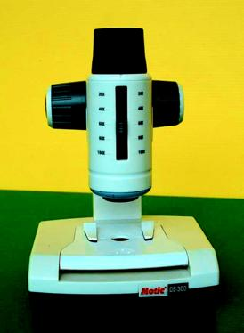

Steps
- Switch on bottom light
- Place slide into clips on stage
- Move magnification to X100
- Lower objective lens until just above slide (using focus knob)
- Look through eyepiece and slowly turn focus knob until object on slide is clear

