The blood types of the four suspects are available from medical records and are shown in the table below. Are your results the same?

Name | Blood Type
  Jenkins | O
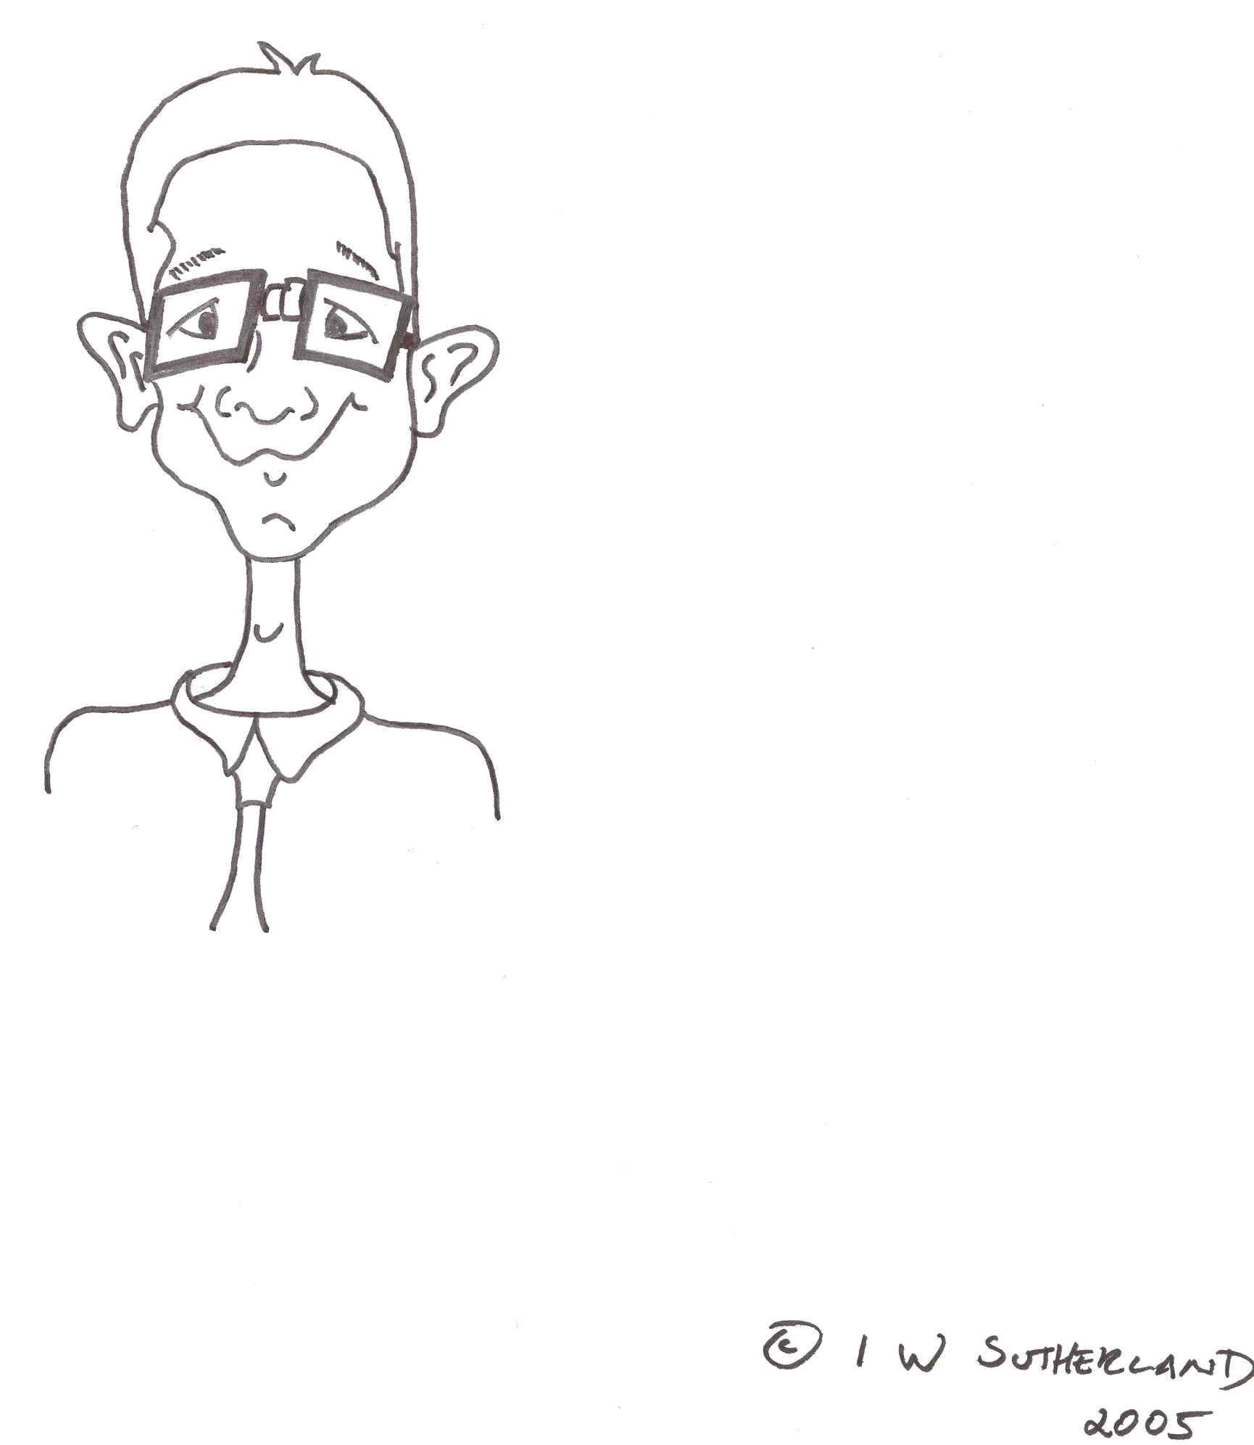  Munro | AB
  Smith | O
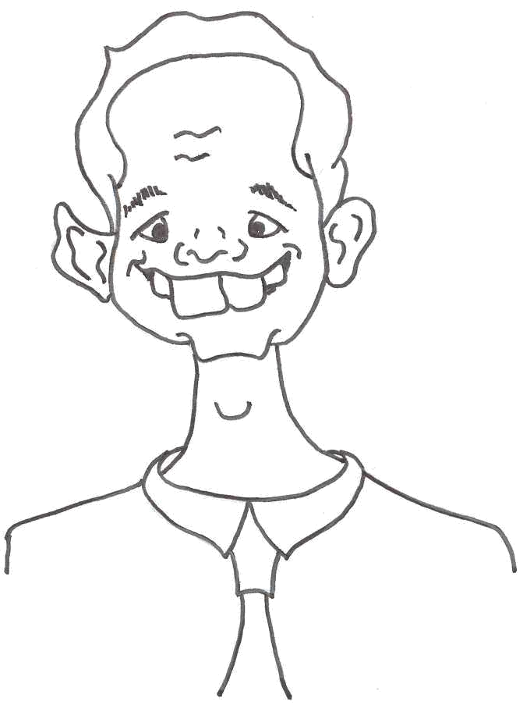  Walker | B

