Teeth Impressions Teeth impressions

Top Top

Bottom Bottom

Name Name
Date Date

Teeth Impressions Teeth impressions

Top Top

Bottom Bottom

Name Name
Date Date

Dental impressions

How to take teeth impressions.

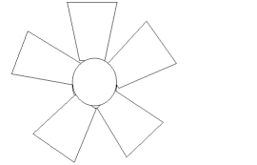
We have found that the best material for making usable impressions is expanded polystyrene as found in insulated cups.
You can get five suitably sized pieces from one cup.

Use two pieces together to get upper and lower
impressions. Label them as “T”(top) and “B” (bottom).
Hold them together, put them in the mouth and bite down.
The impressions can be made clear by rubbing over with a wax crayon. If you have used a dark coloured crayon you will be able to photocopy the tooth patterns.
If children have studied tooth types they may be able to identify the number of incisors, canines etc in the dental impressions. It is unlikely that you will be able to get a complete tooth set including the back molars, but you should have enough to identify your “suspect”.

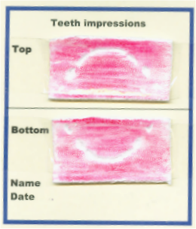


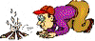
Making a good impression!

It is a holiday weekend and the cubs are off to camp. They have been doing lots of great activities and are enjoying being away with their friends. Because they are so active they are using up lots of energy and the cook is making plenty of good food for them.



On Saturday night she decides to make them toasted cheese for supper. But when she opens the food box to get the cheese slices she finds that someone has been there before her! Some cheese is missing and she even finds a slice that has teeth marks in it. She tells the leader, who is really cross.

The leader talks to the boys but no-one will admit to stealing the cheese. “No toasted cheese until we find the culprit”, declares the leader, “and I know just the way to do it”.


“We will have to become detectives and carry out a forensic investigation to find out who has a set of teeth that match the tooth impressions left in the cheese.
You can all help and we have everything we need right here in camp.”

