Footprint from the desk

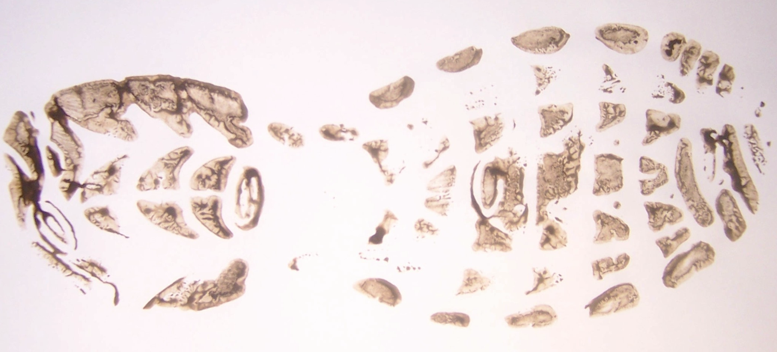
Suspects’ Trainers

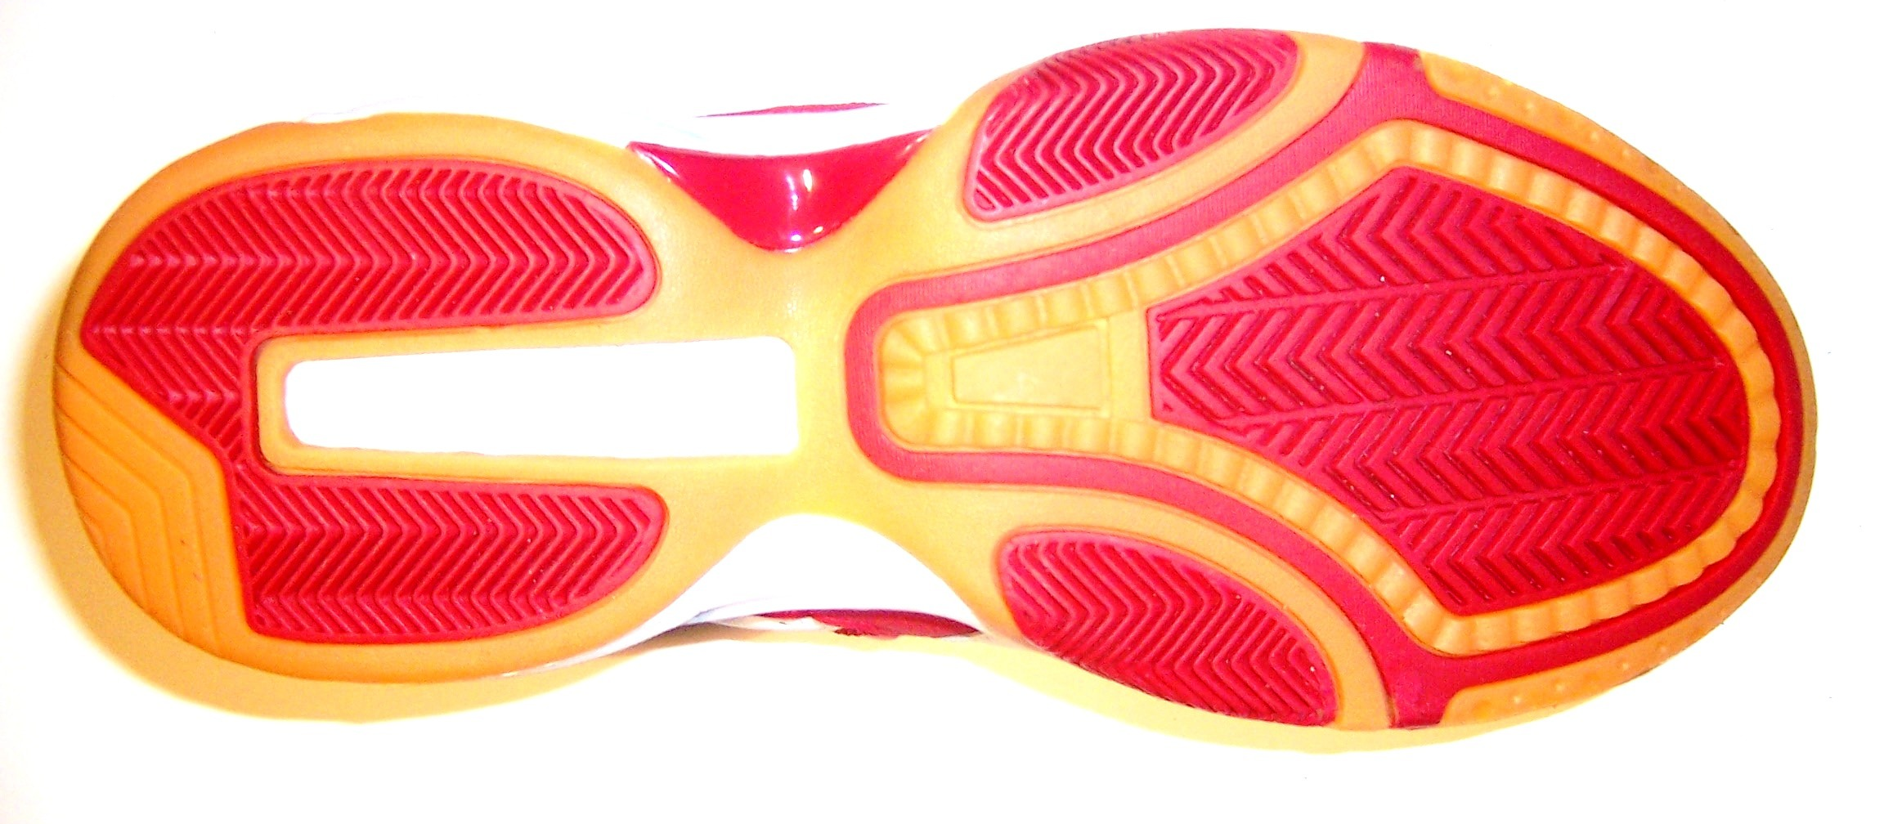  Wayne  Walker | Suspect? Reasons?
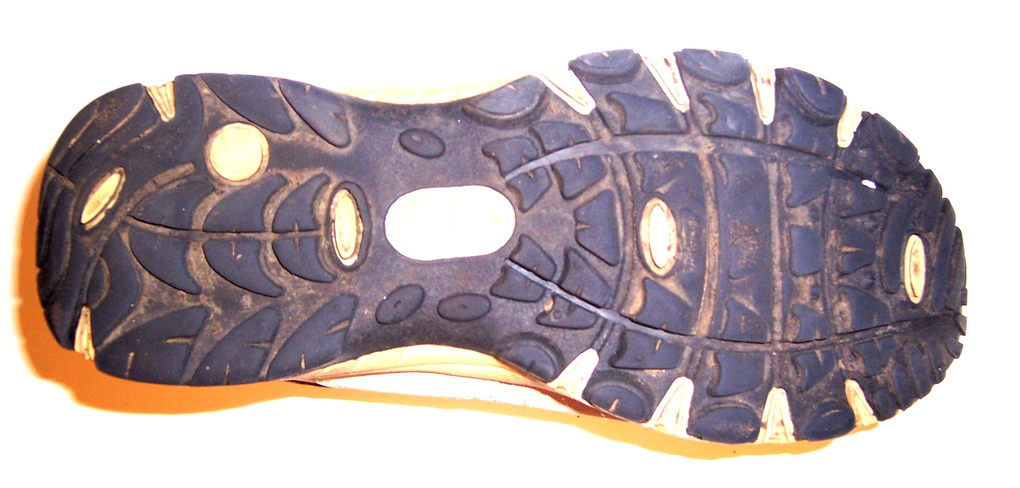  Jamie  Jenkins | Suspect? Reasons?
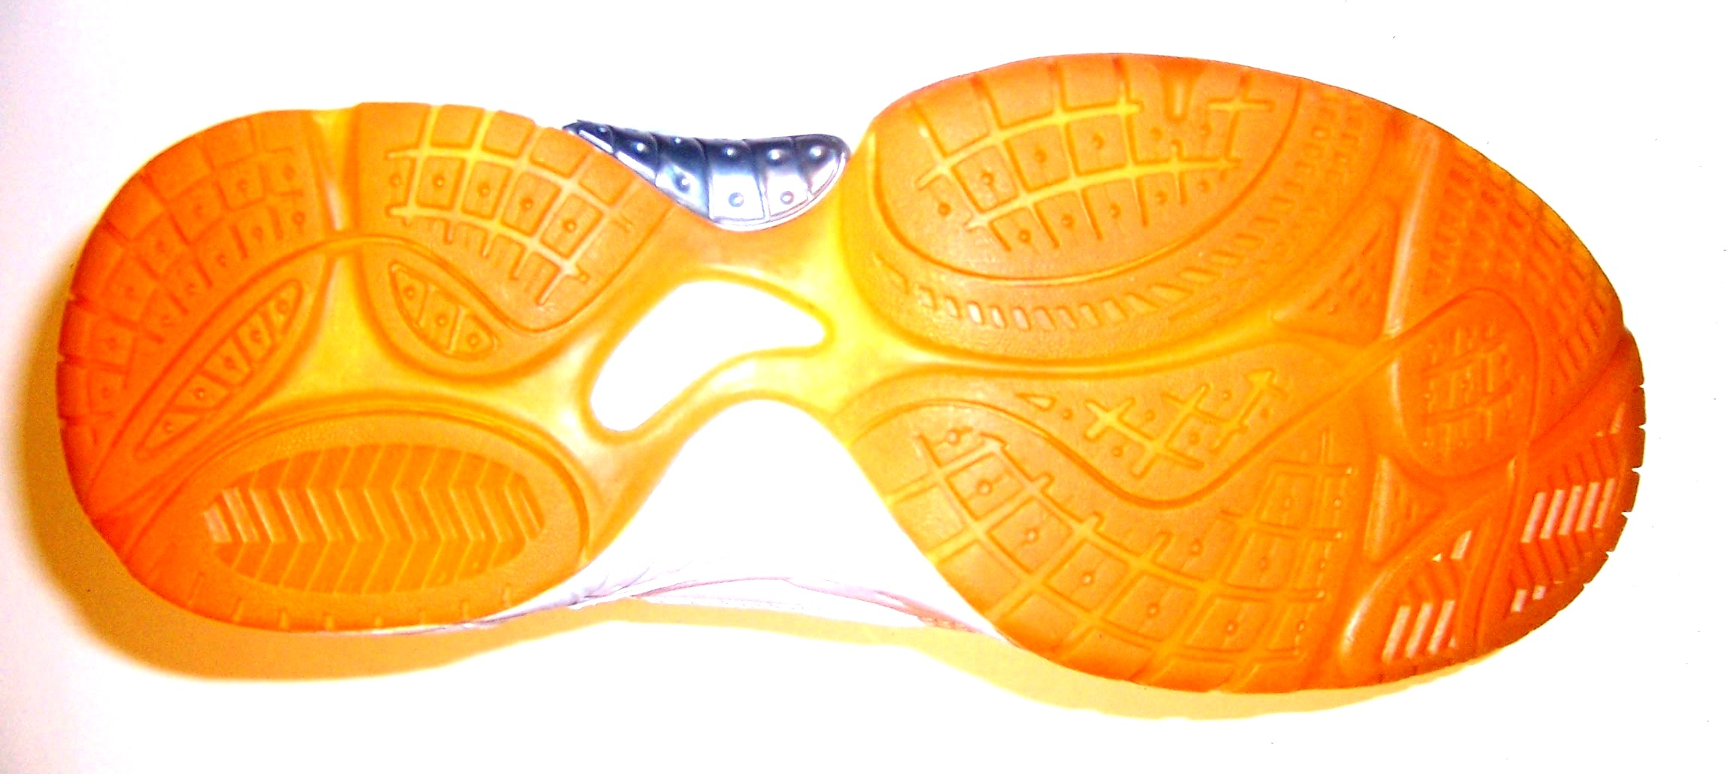  Dougal  Munro | Suspect? Reasons?
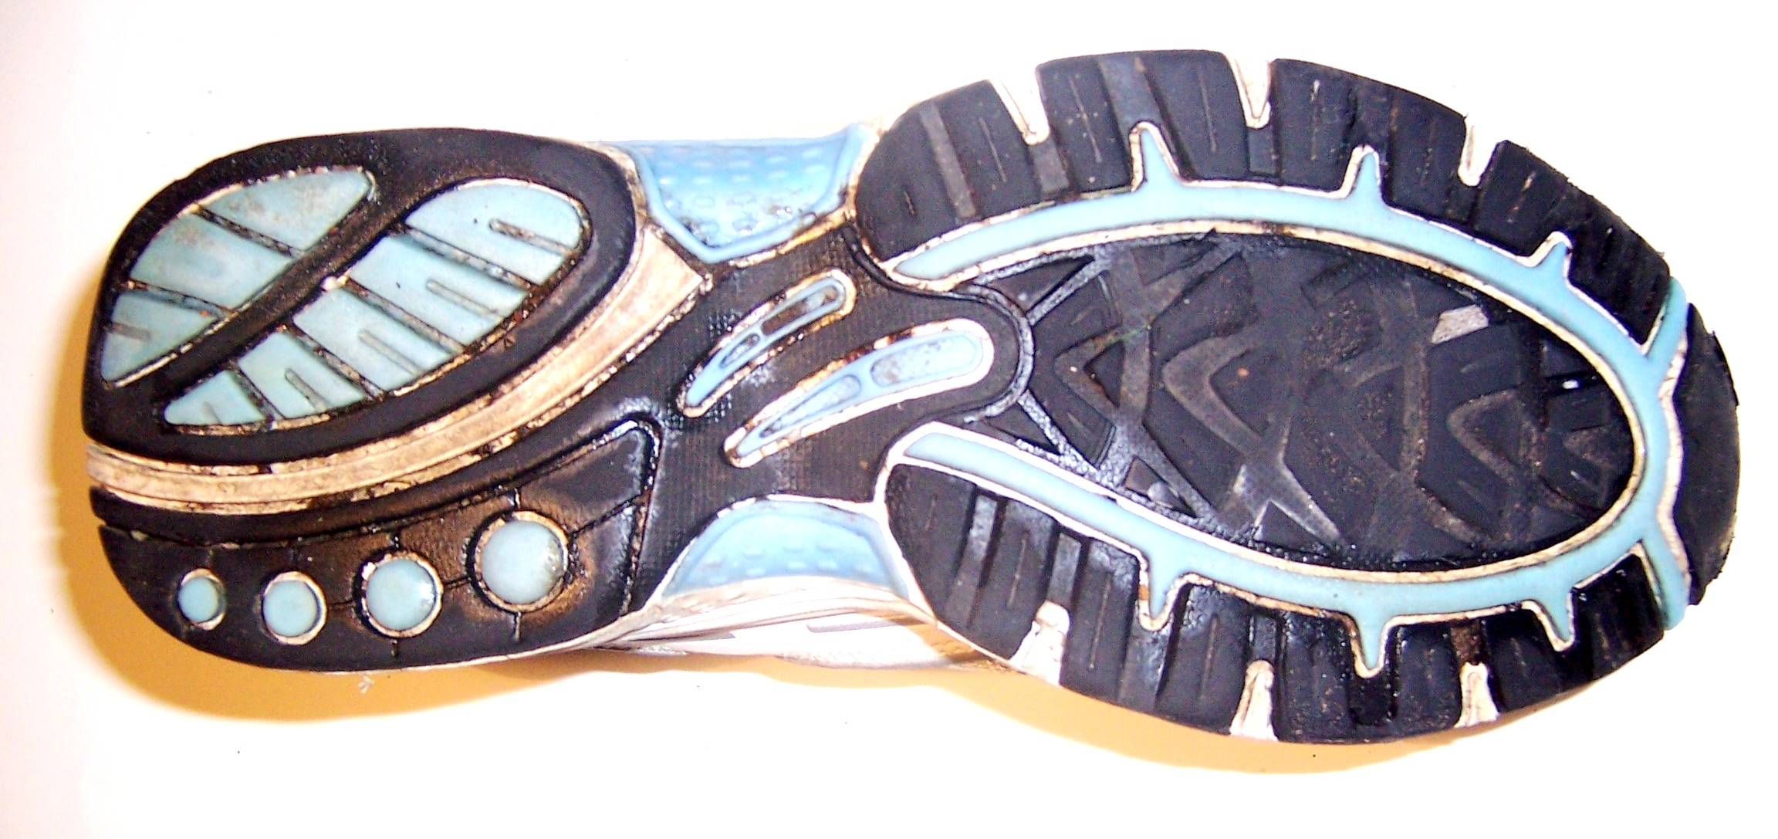  Claire  Smith | Suspect? Reasons?
Someone Else? | Reasons?

Now Turn Over / ........

- What clues did you look for when you compared the photographs?

- What type of photograph do detectives often look at when they are studying photographic evidence from a crime scene? Explain your choice.

- Could any one of the suspects have visited the area where the crime took place? Explain.

- Could any of the other suspects have visited the area where the crime took place? Explain.

- Could another unknown person have visited the area and committed the crime? Explain.

- Is it possible to prove who carried out the crime from your evidence? Explain.

