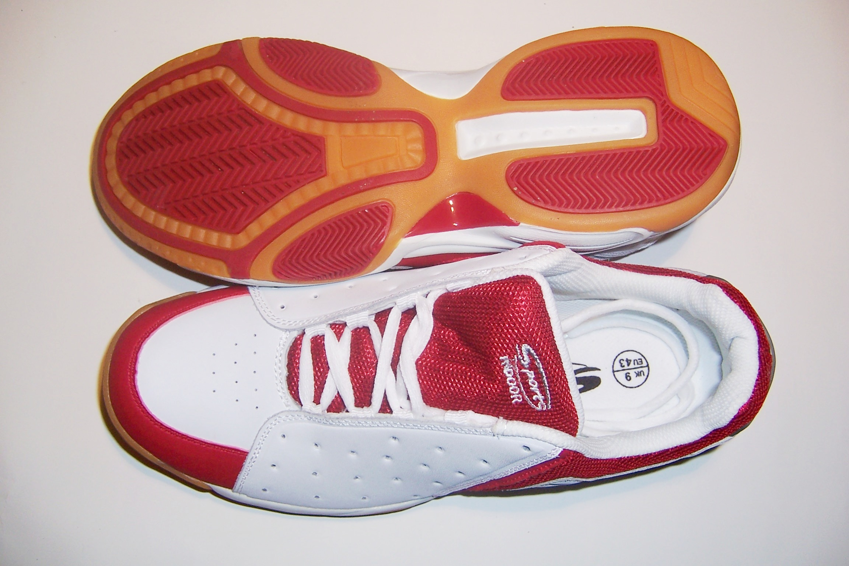
A trainer shoe has many parts made from polymers. Polymers are synthetic (man-made) materials. The sole
of the trainer is made from a material called poly(styrene-butadiene-styrene). Leather and nylon are used in the panels, and the laces can be made from cotton. Cushioning in the shoe is made from natural rubber and polyurethane.

Natural rubber is a compound called polyisoprene. The ancient Mayans and Aztecs harvested it from the hevea tree and used it to make waterproof boots and the balls which they used to play a game similar to basketball. It is what we call an elastomer. (That means it recovers its shape after being stretched or deformed). Normally, the natural rubber is treated to give it crosslinks, which makes it an even better elastomer.


Synthetic rubber has been around for less than a hundred years.
It can be synthesized from chemicals in crude oil. During
World War II there were shortages of natural
rubber so governments began to build factories to produce
synthetic rubber to cope with the demand. Although
man began experimenting with synthetic in 1906, it was
not until not until after World War II that the quality
improved to the point that it rivalled that of natural rubber.

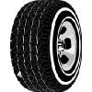
Synthetic rubber factories were built around the world after 1945, mainly in Europe, North America, and Japan. Since 1960,the amount of synthetic rubber used each year has been greater than natural rubber.

However, whether it's natural or synthetic, rubber in its native form is virtually useless. But after chemicals are added, it changes. Depending on the chemicals used, products made of rubber can be as soft as a sponge, as elastic as a rubber band, or as hard as a bowling ball. As a result, we use thousands of rubber products with varying degrees of hardness each day.

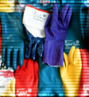
We use products made of rubber at work, at home, at play, and even when we travel. Cars, trains and aircraft rely on it for safety and comfort. Industry uses it to produce hoses, belts, gaskets, tyres, mouldings, and thousands of other products.

The polyurethanes used in trainers are the most well known polymers used to make foams. The cushion in most padded chairs is made from a polyurethane foam. However, polyurethanes can be used to make more than foams. They can also be paints. They can be fibres, and they can be adhesives. Lycra is even a polyurethane. It is used as a fibre in socks to stop them falling down and in swimwear, cycling shorts and leisure wear.

Nylons are one of the most common polymers used as a fibre. Nylon's first real success came with its use in women's stockings, in about 1940. They were a big hit, but they became hard to get, because the next year the United States entered World War II, and nylon was needed to make war materials, like parachutes and ropes. But before stockings or parachutes, the very first nylon product was a toothbrush with nylon bristles. Nylons are also called polyamides.

