On the sheet ‘Be a Soil Detective’ you discussed how the photograph of the footprint might be able to give some clues as to who the culprit might be.
You are going to look at pictures taken of the suspects’ trainers.
What do you need?


A colour photograph of all the suspects’ trainers
A black and white photograph of all the suspects’ trainers
A hand lens

Examine each of the two photographs with the hand lens.

- Which photograph gives the clearer information?

- Which type do you think detectives often use when examining photographic evidence of a crime scene?

What do you need next?

A photograph of each the suspects’ trainers
A photograph of the shoe print on the desk
A hand lens

Now Turn Over / ........

What you do next

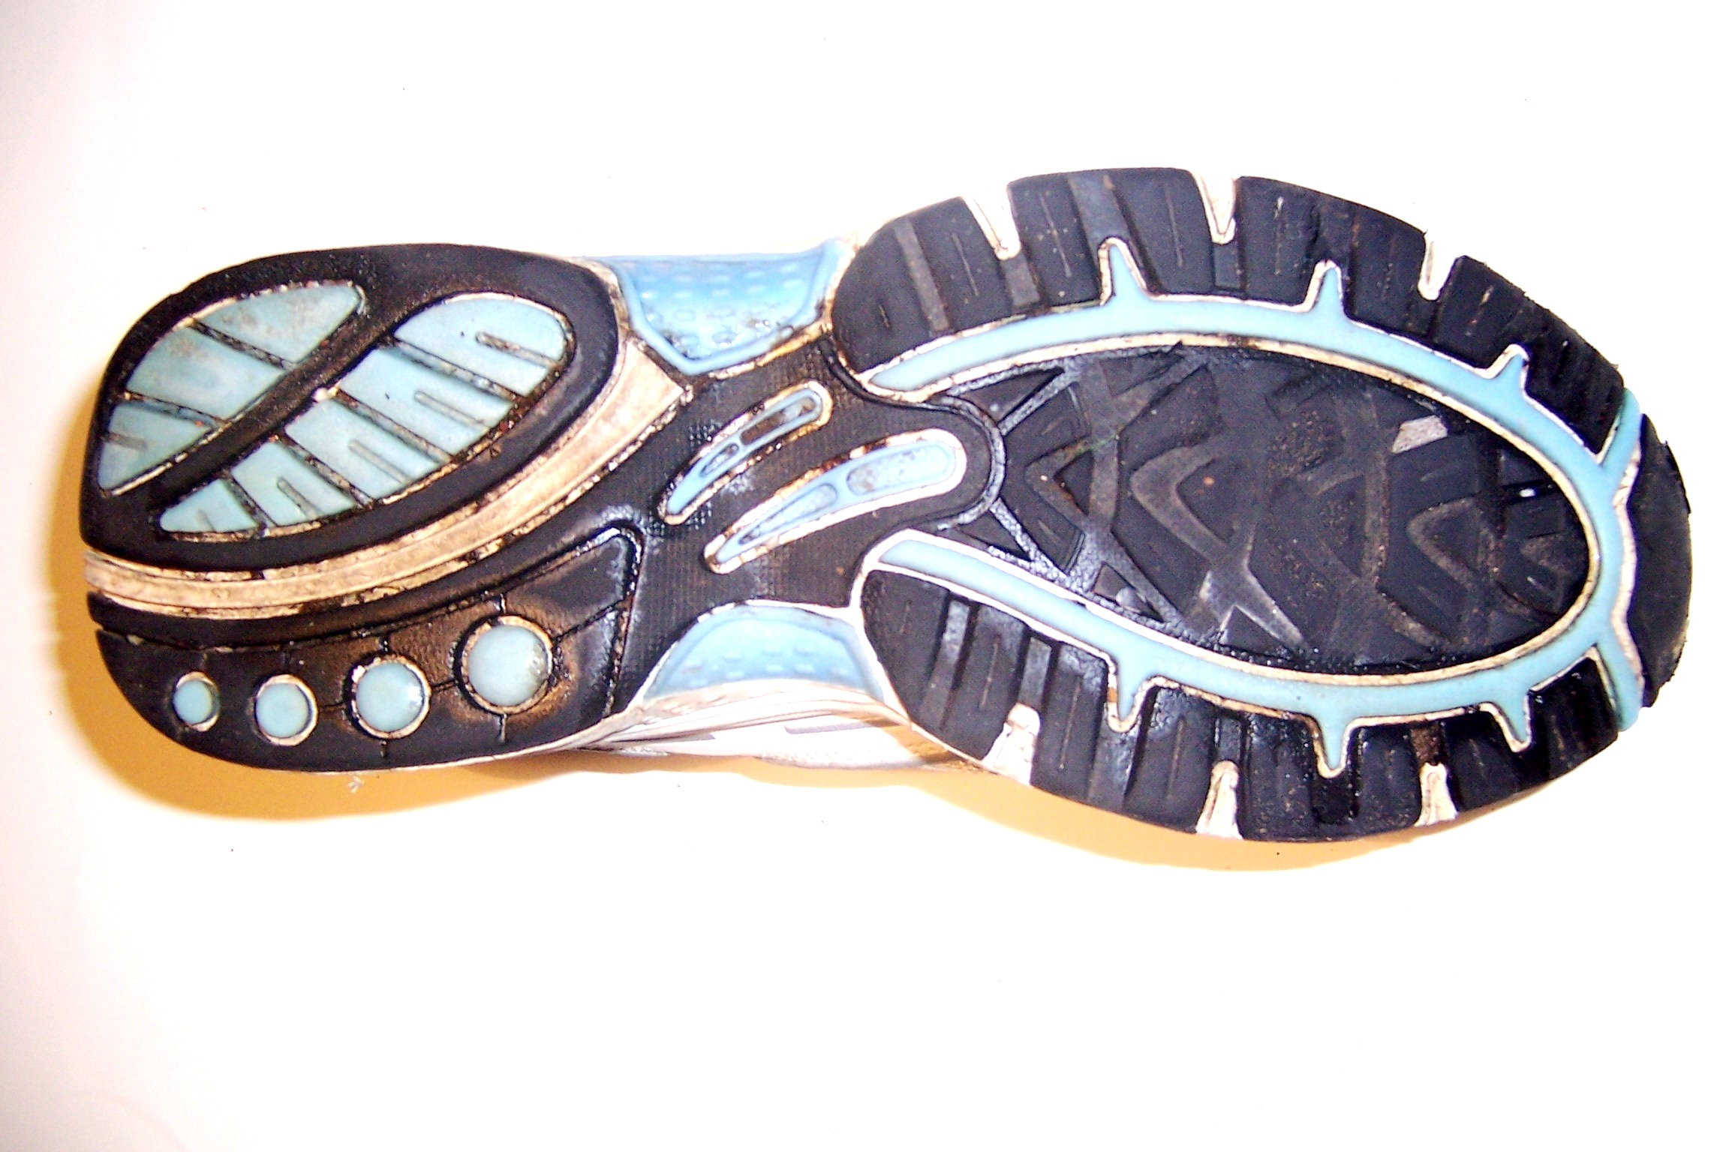
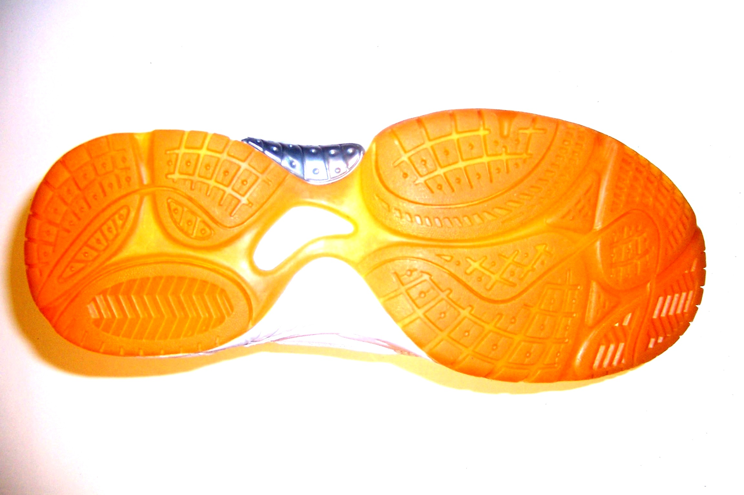
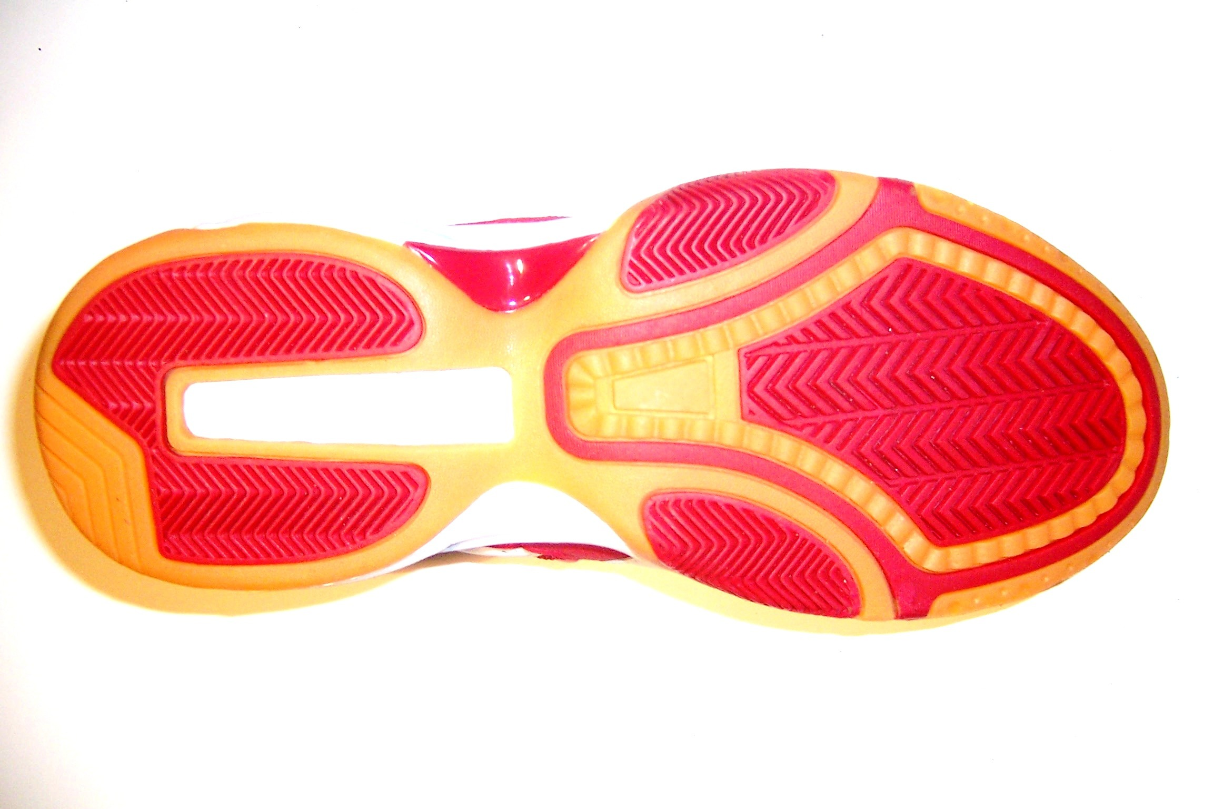
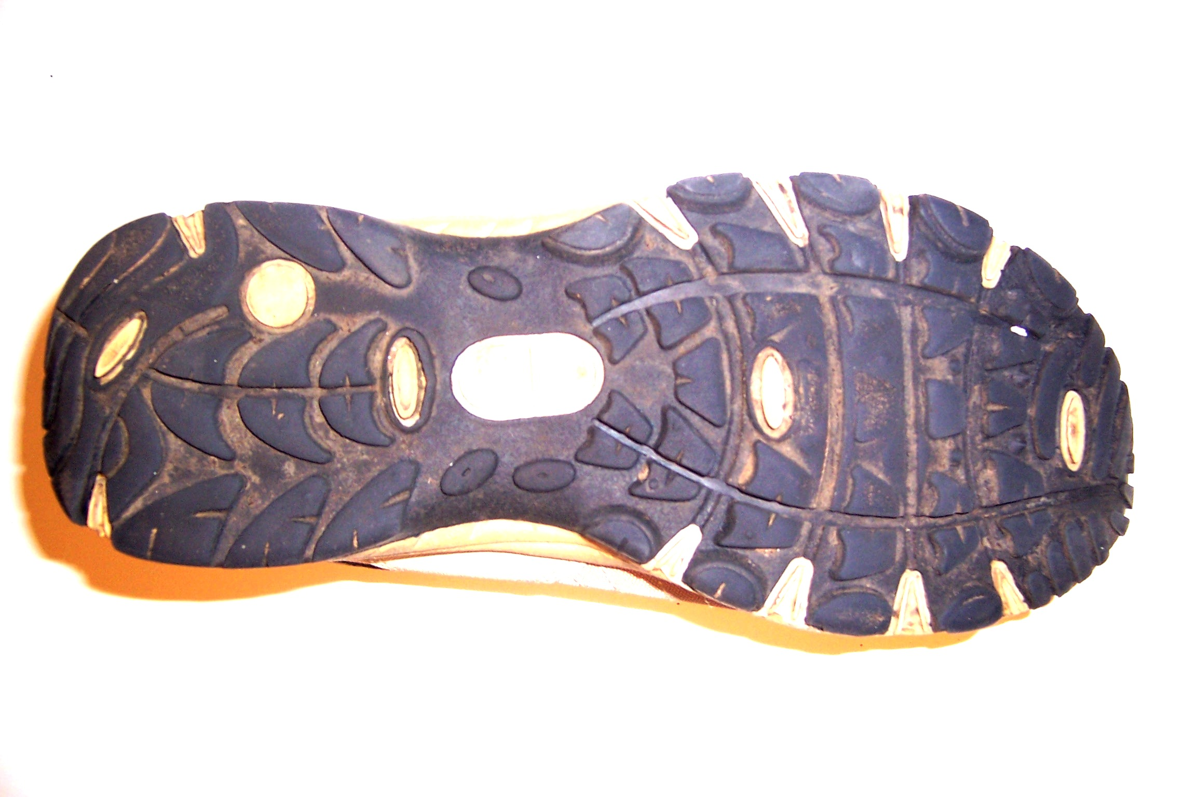
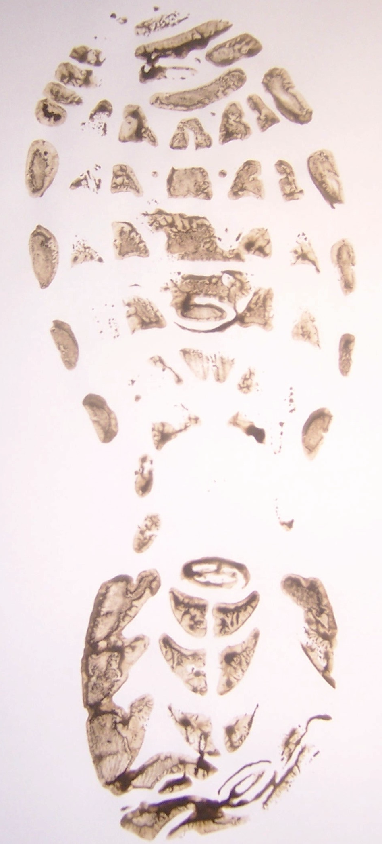
?

- Take one of the photographs of a suspect’s trainers and use the hand lens to compare it with the photograph of the shoe print from the desk. Try to decide if the prints match up.
- Repeat this examination with each of the photographs of the trainers from each of the suspects.

- You will now have to prepare a report on your examination of these items of evidence. You can make your report in draft form until you are satisfied with it. You may wish to consider the following points:

- What clues you looked for when comparing the show prints.

- What type of photograph you looked at (black and white or coloured) and why.

- Could any one of the suspects have visited the area where the crime took place? On what do you base your evidence?

- Could any of the other suspects have visited the area where the crime took place? On what do you base your evidence?

- Could another unknown person have visited the area and committed the crime? Explain your reasoning.

- Is it possible to prove who carried out the crime from your evidence?

