

Fingerprints

Mum is mad!!
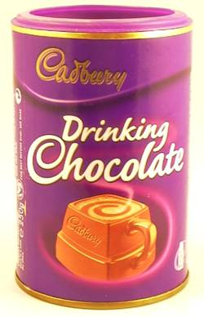
She has just gone into the kitchen and found that someone has knocked the tin of drinking chocolate off the shelf and spilt it all over the floor. They have left such a mess and have not even bothered to try and clear it up.
She does not know who has done it but her son Ben and three of his friends came in for a drink and a biscuit earlier on and so it might be one of them.

Mum sees that one of the dirty glasses left by the sink has a fingerprint in drinking chocolate powder on it. Ah ha! She decides to call the boys in from the garden and suggests a new game to them.
“How would you like to be detectives?” she asks. “All good detectives have to be able to take fingerprints and examine them and I can show you how to do it.”
Can you think why Mum is suggesting this game to the boys?

Here are the different patterns of fingerprints:

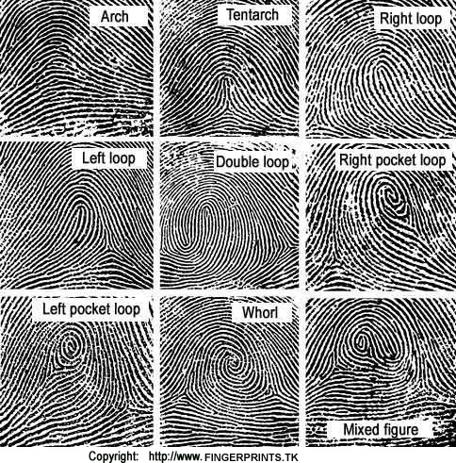

You can look closely at the fingerprints you have made and find out which patterns you can see on your prints.

You could find out which patterns are the most common among the members of your class, or compare your fingerprints to those of others in your family.

How to take fingerprints

There are several good ways to take fingerprints. The best known is to press the finger on to an ink pad and print the pattern on to white paper.

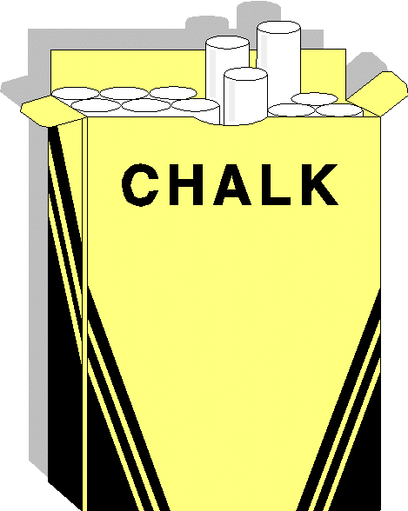
Here are some other ways that use readily available materials. Choose the method you want to try or try different methods and compare them.

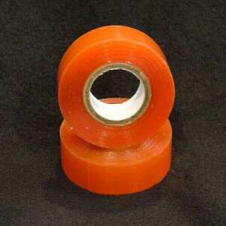
Method 1.

You need:
Sticky tape, Chalk stick, Black paper

Cut a piece of sticky tape (about 6 or 7cm long) and lay it face up on the desk.
Rub over the finger with a bit of chalk and press the finger down on to the sticky tape.
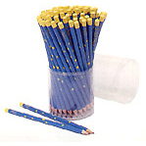
Stick the tape on to your black paper.

Method 2.

You need:
Sticky tape, scrap paper, a lead pencil, white paper

Scribble a patch (about 5cm square) on your scrap paper with a lead pencil, make it nice and thick.
Rub the finger for the fingerprint in the scribbled patch. Press down the “dirty” finger on to the sticky tape.
Turn the tape over and stick it to the white paper.
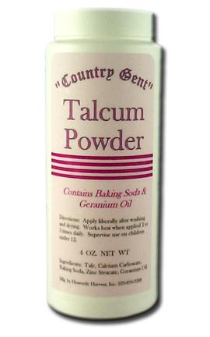

Method 3

As method 1, but use a thin layer of talcum powder instead of chalk dust.

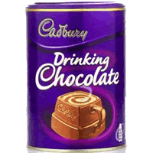
Method 4

As method 2, but use a thin layer of drinking chocolate powder instead of lead pencil patch.

