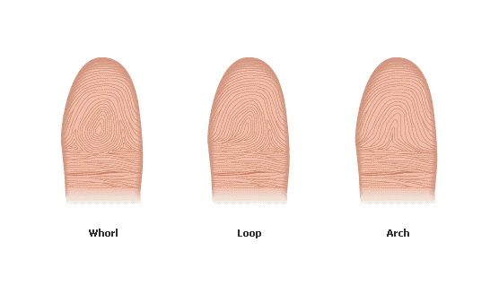
Our fingerprint patterns fall into three main groups called :
whorls, loops, and arches. Loops are the most common.
About 65 percent of all fingerprints are loops. About 30 percent of fingerprints are the whorl type, and arches account for 5 percent.
These are only broad groups.
Within each group there are many more small differences.

All Rights Reserved.
"Fingerprinting,"Microsoft® Encarta®Online Encyclopedia 2006
http://encarta.msn.com © 1997-2006 Microsoft Corporation.
All Rights Reserved.
Place the fingerprint you took from the CD in the place below:

My fingerprint from the CD This is the type called

Whorl Loop Arch

1. R. Thumb 2. R. Fore. 3. R. Middle 4. R. Ring 5. R. Little

6. L. Thumb 7. L. Fore. 8. L. Middle 9. L. Ring 10. L. Little

Try to find others in the class who have the same type of fingerprint as your right forefinger. Use the magnifying glass
to compare them. Although they are of the same type, are they all exactly the same?
Yes / No

