Teacher Guide
Setting the scene
This activity can be used as part of an assessment of skills and knowledge but is intended to be fun!

Item from the crime scene
Provide an article of clothing such as a hat or scarf, or a piece of torn cloth that might have been torn off at the crime scene.

Discussion
What evidence might be provided by an article of clothing found at the scene of a crime?
- Hair
- Blood
- Fibres
- Pollen
- DNA
How could we investigate these?
How could these be used to help solve the crime?
Could these prove who did the deed?

DNA can provide specific evidence to link a suspect to the crime. Web searches will list many examples of DNA fingerprinting being used to determine paternity, ethnic origin, drug dosage, genetic disorders as well as for crime detection.
Genetic profiling is a procedure which analyses the DNA in samples of a person's body tissue or body fluid for the purpose of identifying inherited characteristics. Each person has a different genetic profile. Gel electrophoresis is a technique used to separate pieces of DNA of different sizes. When an electric current is applied, the negatively charged DNA molecules move toward the anode (positive electrode). Small DNA molecules travel through the gel faster than large DNA molecules, giving a pattern of bands which can be seen when the DNA is stained with a blue dye. Gel electrophoresis is an essential part of the process used to identify genes and create a genetic profile.

Curriculum links
explain the role of chromosomes and genes in inheritance
- Explain that chromosomes consist of DNA and that certain sections of the DNA are referred to as genes each of which controls the inheritance of a characteristic.
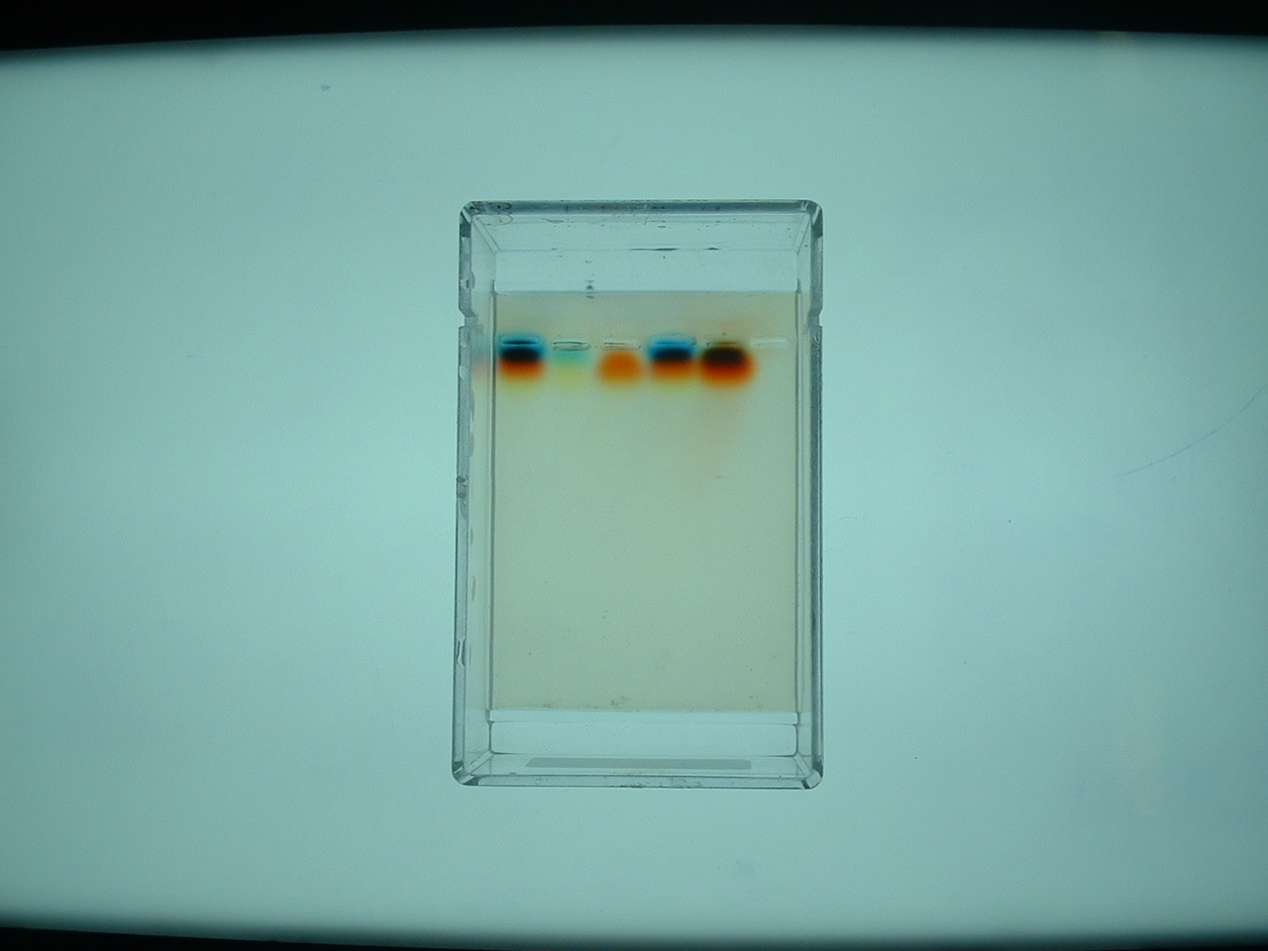

Example results

Technical guide
Gels can be made in advance for the students. Each gel will require about 16 cm³ of molten agar.

- Make up a 3% solution of agar in a flask (add 0.6 g agar powder to 20 cm³ water) and heat on a hotplate or in a boiling water bath until the agar melts and the solution goes clear. Keep swirling or stirring while heating to prevent agar sticking to hot base of flask.
2. Cool agar to 60°C
3. Meanwhile slot the combs into electrophoresis tanks and place on a level surface.
4. Pour the molten agar into the centre of each tank so that it flows between the teeth of the comb. The agar should be about 5mm thick (so that its surface is level with the plastic ridges which form the end channels). Try not to pour agar into these end channels (if it does it can be scooped out later when the agar has set).
5. Leave the gels to set and then remove the combs.
6. Cover the gels with water to stop them from drying out. Top up the water level, if required, when the gels are to be used.

Making DNA (chromosome) samples
These are made from liquid food colourings and Indian ink with the addition of sucrose to help the samples sink into the wells.
Note: colours may vary depending on brand or shade of food colouring (we used Supercook).
To make 3 cm³ solutions, use the volumes and ingredients in the table below.
When making the Indian ink solutions, dilute the ink with 1.5 cm³ of water before adding the food colouring or the ink and food colouring will not mix.
Tube Label | Food colourings
CS | Water 1.5 cm³  Black FC 1.5 cm³
S1 | Water 1.5 cm³  Black II 0.5 cm³  Yellow FC 0.25 cm³  Blue 0.25 cm³  Red FC 0.5 cm³
S2 | Water 1.5 cm³  Black II 0.5 cm³  Yellow FC 0.5 cm³  Blue FC 0.25 cm³  Red FC 0.25 cm³
S3 | Water 1.5 cm³  Black FC 1.5 cm³
S4 | Red FC 0.5 cm³  Blue FC 1.5 cm³  Yellow FC 1.0 cm³
FC = food colouring

II = Indian ink

- Prepare a 50% sugar solution. Weigh 5 gram of sugar and add to 10 ml water. Mix to dissolve sugar in water.
- Measure 2 ml sugar solution into an empty tube. Add ten drops from the crime scene sample solution to the sugar solution. Mix to evenly distribute food colour in sugar solution.
- Repeat steps 1 and 2 for each suspect sample.
- The food colour solutions can be stored indefinitely in the refrigerator.
- Make up the required number of samples for the class – 10 ml sugar solution divided into 5 different colours per group.

- Materials required for each group
Brown/red chromosome samples  Micropipettor  Micropipette tips  Black card  Electrophoresis tank containing agar gel covered with water | Carbon fibre electrodes  Set of +/- electrical wires  3 x 9v batteries  Discard jar

