Miss Taken felt that she needed more evidence to identify which of the suspects could have damaged her classroom and ruined her bouquet of flowers.
The scarf left in her classroom provided many clues (hairs, dust, pollen and blood) but modern forensic science might provide evidence that would enable her to know if one of her suspects was guilty.
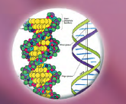
She decided to find out about DNA fingerprinting.
She would need to get samples of DNA from the suspects to find out if their DNA matched samples taken from the crime scene. Blood on the scarf left in her classroom could provide crime scene DNA.

DNA is present in almost all of our cells. It is what makes each of us unique!
DNA controls your appearance (hair colour, eye colour, size and shape, skin tone, etc.). It controls how all your cells work and even what characteristics you will pass on to the next generation!

DNA is a complex chemical found in the nucleus of cells and organised into strands called chromosomes. An individual section of a chromosome is called a gene and each gene influences one aspect of you, from whether you have freckles to how intelligent you are! You have thousands of genes.
Only identical twins have the same DNA but even they may not look exactly the same because our environment (such as how much we eat) can have an effect.

A procedure called gel electrophoresis can be used to analyse DNA. An electric current separates DNA fragments and these appear as bands in a gel made of agar. Each person’s DNA shows some unique bands.

You will now carry out the experiment to analyse DNA from the crime scene and from the suspects.

4 different DNA samples
Crime scene DNA
Micropipettor
Micropipette tips
Black card
Carbon fibre electrodes
Set of +/- electrical leads
3 x 9 v batteries
Discard jar
Electrophoresis tank containing agar gel covered with water

10 μl

- You may want to practice using
the micropipettor first! You will
have to measure out 10 μl twice
to fill each well. Depending on the amount of gel, you may not need the full 20 μl. It is important you do not let the wells overflow.
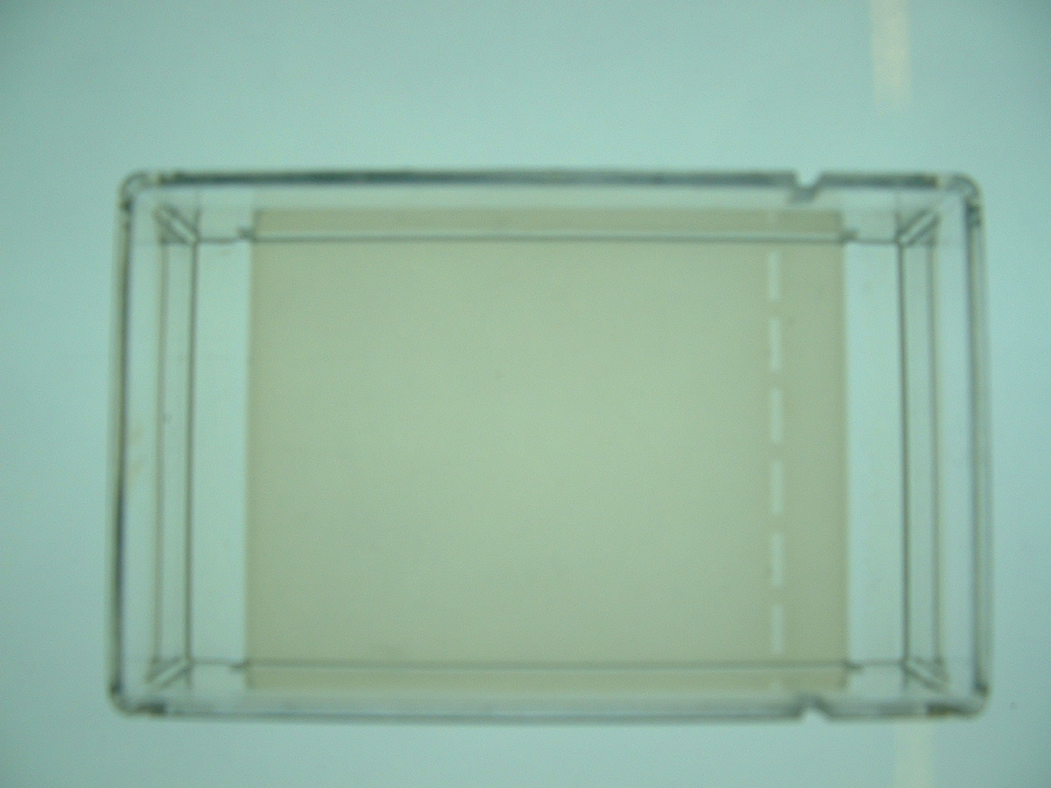
Gel electrophoresis tank
wells
- Using a micropipettor and tip, load the
first well with approximately 20 μl of
the sample labelled CS (crime scene).

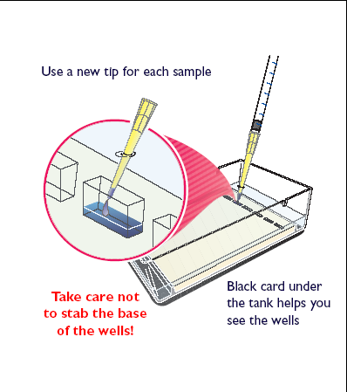
Diagram: Dean Madden NCBE

Place the black card under the tank
to help you see the wells.

Turn Over/..........

- Repeat the first step using each DNA sample in turn till you have loaded:

well 1 - CS | well 2 – S1 | well 3 – S2 | well 4 – S3 | Well 5 – S4

CS | Crime scene
S1 | Jamie Jenkins
S2 | Claire Smith
S3 | Wayne Walker
S4 | Dougal Munro

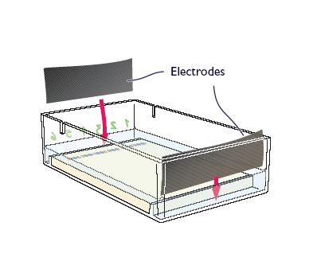
Diagram: Dean Madden NCBE
Diagram: Dean Madden NCBE
- Insert the carbon fibre electrodes at each end of the tank and attach the crocodile clips to them. The black (-ve) clips go at the end nearest the wells.

- Wire up the electrophoresis
tank to the batteries, with the
red clip at the vacant +ve
terminal of the battery and
leave for 30 minutes.
You should see bubbles at the
negative carbon fibre
electrode if your gel is ‘running’.

- While the electrophoresis is running, carry out the tasks
on the ‘Be a DNA Detective’ sheet.

- Now return to the experiment and remove the wires from the
battery and the tank.

- Pour off the water and examine the gel.

- On the diagram of the electrophoresis tank, draw your results.

