Next day, Miss Taken was still trying to catch the culprits. Something kept on niggling at the back of her mind. Something she had noticed and should do something about. Something to do with inks and colours. What was it?

She decided to talk to each of them. That was when she noticed that ‘The Jamie Jenkins had some patterns drawn on his arm. Almost like tattoos.

‘Yeh – I’m good at art he said. Going to be a famous artist when I leave school. Want to get some tattoos as well but I’m too young just now. Thought I would be cool and do my own just now with a pen”.

“Can I see the pen you used?” asked Miss Taken.

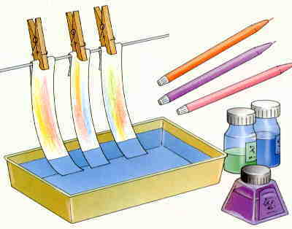
“Sure” sneered Jenkins. Rummaging around in his bag he handed Miss Taken a felt tip pen.

“Chromatography!” exclaimed Miss Taken,
remembering the experiment she had done in a science
lesson at school on inks. Could this help her find the
culprits?

“Kroma – what?” asked ‘Jamie.

“Sorry – nothing”, said Miss Taken, not realising she had spoken out loud. “Is this your own pen?”

“Eh – no, em, I just found it in my bag yesterday”, replied a flustered Jenkins.

“Mind if I borrow it?” asked Miss Taken, casually. “I’ll give it back”.

“Well, OK” said Jenkins reluctantly, “but why are you not taking pens from the others too?”

Of the others, Wayne Walker didn’t have any pens Dougal Munro had a felt tip pen and so had Claire Smith. Miss Taken got those as well.

You are now going to be chromatography detectives to help Miss Taken work out if one of these pens could have been used to write the note.

In this experiment you are going to use a technique called chromatography.
The name comes from two Greek words chroma and graph and means colour writing. The technique was developed by a Russian botanist called Mikhail Tsvet in 1910 when he was trying to work out what coloured pigments were in leaves.

If you have ever spilled water on your homework and seen the ink run, you have witnessed paper chromatography. You are going to carry out paper chromatography on a sample of ink from the note left at the scene of the crime, and also on two pens found on the suspects.
What do you need?


Four round pieces of filter paper
A watch glass
A piece of the note from the crime scene
Tweezers (for handling the letters)
The three felt tip pens
A dispensing bottle filled with water.
A hairdryer

What you do

- Place one piece of the filter paper on the watch glass.

- Use the tweezers to remove a small piece of the writing from
the note and place this in the centre of the filter paper.
- Carefully place 5 drops of water on the ink of the note
using the dispensing bottle and watch what happens.

- When the water has stopped spreading out remove
the paper and dry it with the hairdryer.
- Stick this in the space provided on the sheet called Chromatography Analysis.
Turn Over/……………

- Take a second piece of the filter paper.
- Use the first pen to make an ink spot in the centre of the circle.

- Place the piece of the filter paper on the watch glass.

- Once again add 5 drops of water to the ink
spot and watch what happens.

- When the water has stopped spreading out remove the paper and dry it with the hairdryer.

- Stick this in the space provided on the sheet called Chromatography Analysis.

- Now repeat steps 6-11 twice more, but use the third piece of filter paper and the second pen and finally the fourth piece of filter paper and the third pen.

- Stick this in the space provided on the sheet called Chromatography Analysis.

The inks in most non-permanent markers are made of different coloured pigments mixed together with water. When you write on paper, the ink puts the pigments on the paper and when it dries, the colour is left on it. When you put drops of water on the ink, the dried pigments dissolve. As the water travels out from the centre, it carries the pigments with it. Different coloured pigments are carried at different rates. Some travel further and faster than others so the colours get separated. How fast each pigment travels depends
on things like how big the pieces of pigment are, how well they are attracted to the paper and how well they are attracted to the water. By looking at and comparing patterns, you can work out if similar pigments were used in the ink
in different pens.

Ask your teacher if you should complete the Discussion Sheets or the Question Sheets about your experiment.

