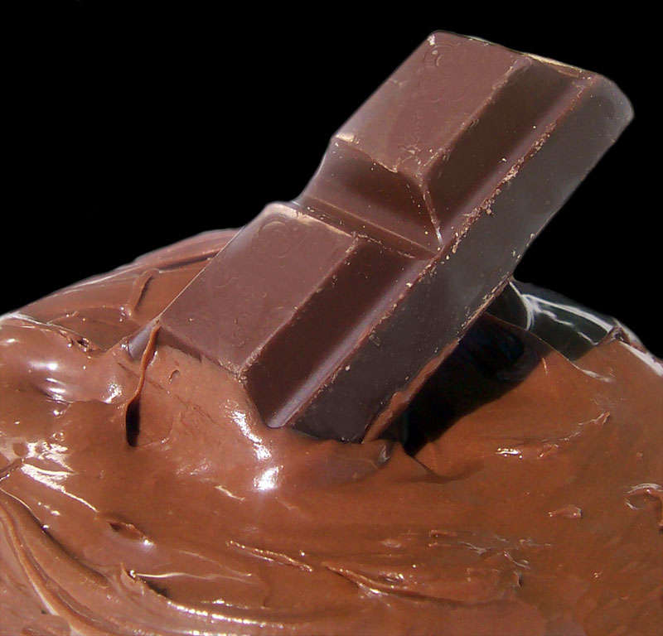
Miss Taken was livid! Someone had stolen half her bar of chocolate from her desk drawer. What sort of person would torture her like this and leave her half a bar?

She had left it in the pocket of her jacket which had
been hanging over the radiator. When she took it
from the pocket it was all melted with the heat.
However, 10 minutes in the staff room fridge and it
had turned solid again, ready to be eaten.

http://en.wikipedia.org/wiki/User:Fir0002/Fir0002_gallery/Kodak/Other

Of the four suspects, Wayne Walker did not have any chocolate and neither did Claire Smith. Dougal Munro had 2 squares in his pocket but one was covered in pieces of fluff. Jamie Jenkins had said he didn’t eat chocolate because it gave him spots, but when he emptied his bag half a bar of it fell out. He couldn’t explain where it had come from.

When Mr Oliver the Chemistry Teacher heard that Miss Taken’s chocolate had been melted and then solidified again, he remembered something he had read about chocolate. This said that the cocoa butter in chocolate changed when it was melted and then re-solidified. This changed how easily it snaps, it strength, glossiness and texture.

Perhaps Miss Taken could compare the glossiness and ‘snap’ of the samples to see if they were different. If she was not in a lab, she could even taste a piece of each to see if the texture and taste was any different. See if you can help her work out if one of the suspects could have stolen her chocolate.

What do you need?



Samples of chocolate from each of the two suspects
The sample of chocolate from the classroom
Sample of ordinary chocolate

What you do

- Do not eat the evidence (at least not in the lab!).
- Look at the glossiness (shine) of the samples. Are they dull or shiny?
- Try snapping the samples in two. How easy is it to do this? Is it harder to snap some than others?
- Your teacher may allow you to taste each sample out of the lab.
If you eat do get a chance to do this, note the taste and texture of
one of the samples and how easy it melts in your mouth. Then rinse your mouth with water. Repeat the experiment with each of the other samples.
- Record all your findings on the Analysis Results sheet.

Chocolate | Glossiness Test  (dull or shiny) | Snap Test  (easy or hard) | Taste and Texture and ease of melting (fill in only if done)
from
the
desk
ordinary chocolate
(contains type V cocoa butter)
from Jamie
Jenkins
from Dougal Munro

The ability of the cocoa butter to take on many different crystal forms is called polymorphism. (Poly means many; morph means shape). The details of the polymorphism of chocolate are very complex and this is still an area of active research. It is known, however, that one of the six polymorphs has far superior taste and texture than the other ones – the one known as form V. It is also the glossiest and snaps well. This is the type used in chocolate you buy. Table 1 shows some of the characteristics of different cocoa butter polymorphs.

Table 1

Cocoa Butter Polymorphs
Polymorph | Conditions to make the polymorph | Melting point (°C)
Form I | Rapidly cooling molten chocolate | 17.3
Form II | Cooling the molten chocolate at 2°C | 23.3
Form III | Solidifying the molten chocolate at 5-10°C or storing form II at 5-10°C | 25.5
Form IV | Solidifying the molten chocolate at 16-21°C or storing form III at 16-21°C | 27.3
Form V | Solidifying the molten chocolate while stirring. Needs a special process called ‘tempering’ | 33.8
From VI | Storing form V for 4 months at room temperature | 36.3

Mr Oliver was pretty sure he could try a different experiment with the chocolate samples:

- He had found some results in an old textbook for melting chocolate. He knew he could test the melting point of the samples of chocolate he had been given by Miss Taken and to compare his results with the textbook answers. The melting points would vary slightly depending on the experimental conditions such as

- the type of chocolate used
- the temperature of the water used to melt the chocolate
- the quantity of chocolate used
- how well the mixture was stirred

However, he was pretty sure he could get good results and could then plot graphs. He might learn something by comparing them. It might show if one of the samples had been pre-melted or was ordinary chocolate containing Type V cocoa butter.

You are now going to look at Mr Oliver’s results for the experiments he did on the chocolate samples. See if you can help him work out if one of the suspects could have stolen the chocolate from Miss Taken.

Chocolate from | Time (s) | 0 | 30 | 60 | 90 | 120 | 150 | 180 | 210 | 240
the  desk | Temperature (ºC) | 22 | 28 | 31 | 35 | 39 | 41 | 43 | 45 | 47

Ordinary chocolate  (contains | Time (s) | 0 | 30 | 60 | 90 | 120 | 150 | 180 | 210 | 240
type V cocoa butter) | Temperature (ºC) | 24 | 28 | 32 | 34 | 34 | 39 | 42 | 46 | 48

Chocolate found | Time (s) | 0 | 30 | 60 | 90 | 120 | 150 | 180 | 210 | 240
on  Jenkins | Temperature (ºC) | 22 | 27 | 31 | 36 | 40 | 42 | 44 | 46 | 48

Chocolate found | Time (s) | 0 | 30 | 60 | 90 | 120 | 150 | 180 | 210 | 240
on  Munro | Temperature (ºC) | 23 | 27 | 30 | 34 | 35 | 40 | 44 | 46 | 47
What you do

You must plot graphs of these results.

Remember these checks when plotting a graph:

Each axis must have a label
If an axis involves numbers, the scaling must be correct
If an axis involves numbers, there must be units in the label to
say what it is measured in
If words and numbers are being plotted, a Bar graph is used
If numbers and numbers are plotted, a Line graph is used if the
number scale is continuous
Each bar or point must be correctly plotted
For a line graph the points must be correctly joined

Ask your teacher for graph paper sheets. You should try to produce your
graphs using the above check list to help you.

However, if you can’t think of the names for the labels or make up the scales,
you will be able to get some graph paper with these already done for you.

Chocolate dates back to the ancient Maya
people of Central America. They first used the beans from cocoa trees growing in the tropical rainforest of the Amazon Basin to make a bitter drink they called xocolatl.
Xocolatl was made by roasting and grinding the cocoa beans and then mixing them in water with maize meal, vanilla and chilli. The Maya also used cocoa beans as a currency and as gifts at ceremonies. According to a 16th century Spanish chronicle, a rabbit was worth 10 cocoa beans and a mule cost 50 beans. Maya traders took the cocoa beans to Mexico to sell to the Aztecs, and it was a great hit there too. They had been drinking xocolatl for hundreds of years by the time the Spanish arrived on the Continent.
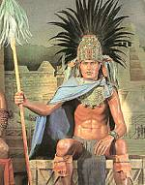
A Spanish explorer called Don Cortez is
said to have drunk this thick chocolate drink
out of a golden goblet with the Aztec emperor
called Montezuma. It is also said that Montezuma
drank about 50 goblets of chocolate every day!

Copyright www.aztecdahlias.com
Don Cortez brought cocoa beans, along with chocolate-making equipment, back to Spain in 1528, and the Spanish soon developed a taste for the drink. They made their own version of xocolatl. They omitted the chilli pepper and added cinnamon, nutmeg and sugar instead.
Its recipe remained a secret for about a hundred years and didn’t arrive in Britain until the 1650s. Even then the beans were in short supply so it was very expensive to buy.
Chocolate for eating was not invented until early Victorian times. The first bar of chocolate was produced by Fry and Sons in 1847 and by Cadbury two years later. Milk chocolate was produced for the first time by Henry Nestlé about 30 years later.

Cocoa beans grow in countries near the Equator such as, Brazil, The Ivory Coast, Ghana, Nigeria and Malaysia where the climate is steamy and damp.
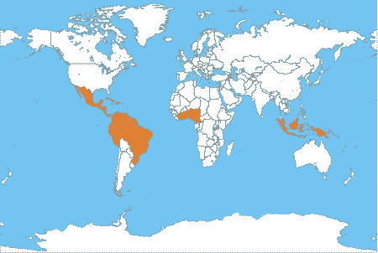

http://www.globaleye.org.uk

The beans form in football shaped pods that grow straight out from the tree trunk. The pods are harvested and the beans extracted, fermented and roasted before being shipped to the chocolate manufactures.

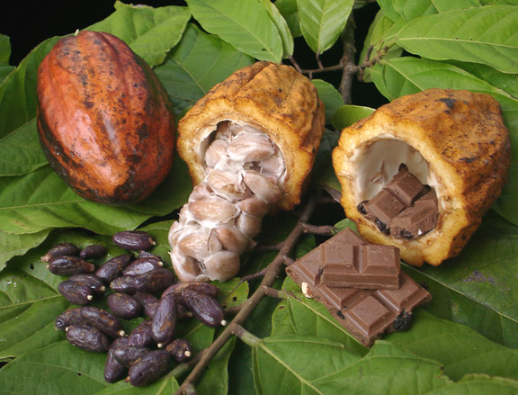

Copyright : Fruit Lover's Nursery, www.fruitlovers.com

Successful chocolate making requires an understanding of the tastes of the people eating it. People in the UK, the USA and Europe prefer different tasting chocolate. so taste, texture, gloss, ‘snap’ and other properties are altered during the complex chocolate making processes to cater for their different tastes and perceptions of how it should look.
Chocolate making begins with mixing the ingredients and grinding to give a mixture of correctly sized particles. The size is vital to the ‘mouth feel’ of the chocolate bar and is typically about 0.02mm. The next stage is known as ‘conching’. This involves removing volatile compounds and adjusting the moisture content and viscosity. This gives the end product its desired flavour. The mixture is melted, sheared (stirred) and cooled in a complex process known as tempering. The temperature and shearing have to be very carefully controlled or the chocolate ends up brittle, crumbly and tasting different.

Chocolate is a mixture of many chemical compounds. Up to 400 have been identified! The reason that chocolate is so complex is due to the cocoa butter which is a key ingredient in the product. It is a triglyceride formed from the reaction of glycerol (propan-1, 2, 3-triol) with various fatty acids to form a molecule which has the shape of a capital E. The fats are polymorphic (they can take on a number of different crystal forms.) These different forms have their own characteristic melting points and this affects how the product feels in the mouth. The form favoured by the chocolate industry is form V which, with a melting point of 33.8˚C, ‘melts in the mouth’ and is the one generally favoured by consumers.

Scientists and wine connoisseurs say that red wine may be good for you because it contains chemicals called phenols that protect against heart disease. Chocolate contains these anti-oxidants too!
Scientists have found that one 'square' of milk chocolate contains almost the same amount of phenols as a glass of red wine and that plain, dark chocolate contains even higher amounts. One theory suggests that phenols prevent the oxidation of low-density lipoproteins into the 'bad' fats that clog up coronary arteries and cause heart disease.
And if you feel that chocolate gives you a 'lift', well it may just be doing that. Chocolate contains a chemical called phenylethylamine, which is related to amphetamines, and like them raises blood pressure and blood glucose levels'. Dr Peter Barham, at Bristol University has suggested this is what makes us feel alert and gives us a sense of well-being.

