 | Support for Scottish Science Education through CPD | 

Making light of photosynthesis

Carbon cycle game
Teacher information

For each set you will need –
- One tiger picture
- One sunflower picture
- One respiration, one photosynthesis
- One sugar, water, oxygen, carbon dioxide
- Four blue arrows
- Two green arrows
The aim of this activity is to encourage pupils to consider how carbon dioxide, water, oxygen and sugar are utilised by animals and plants by placing arrows in the direction of flow of use. The intention is that pupils will come up with the idea of a carbon cycle, in that carbon dioxide is taken up by plants in the process of photosynthesis and released by both plants and animals in the process of respiration.
Of course, feel free to customise as you see fit!

Sugar | Water
Oxygen | Carbon dioxide
Photosynthesis | Respiration
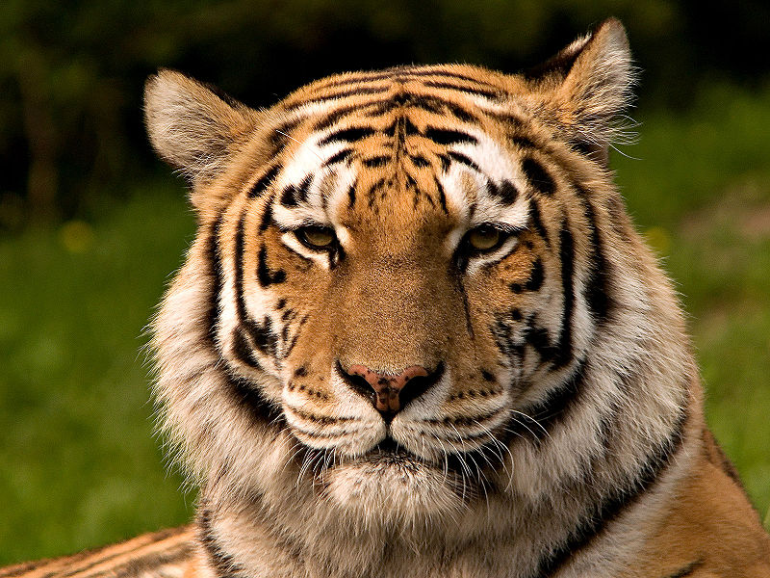  Image from Wikipedia | 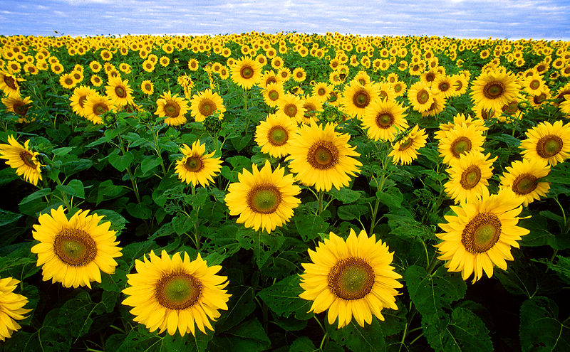  Image from Wikipedia

Image from Wikipedia

