Miss Taken asked if the scarf belonged to any of the suspects or if they recognised it – but there was no reply.
The scarf did not have a name on it and many pupils in the school owned similar scarves!
She decided to find out if she could use stains on the scarf, which looked like blood, to eliminate any of the suspects.
All the suspects were seen wearing a
scarf on the day Miss Taken’s flowers
were destroyed - but, when questioned,
Jamie Jenkins said he had lost his scarf
on the football field.
Claire Smith insisted her scarf was in the wash.
Dougal Munro swore he had lent his scarf to his brother and Wayne Walker could not remember if he even owned a scarf.

Miss Taken found information on blood testing from the internet and thought she could –

  - Use simple chemicals to test if the stain was blood

    - If it was blood, find the type of blood using a blood testing kit

She hoped the results would help her find the culprit.


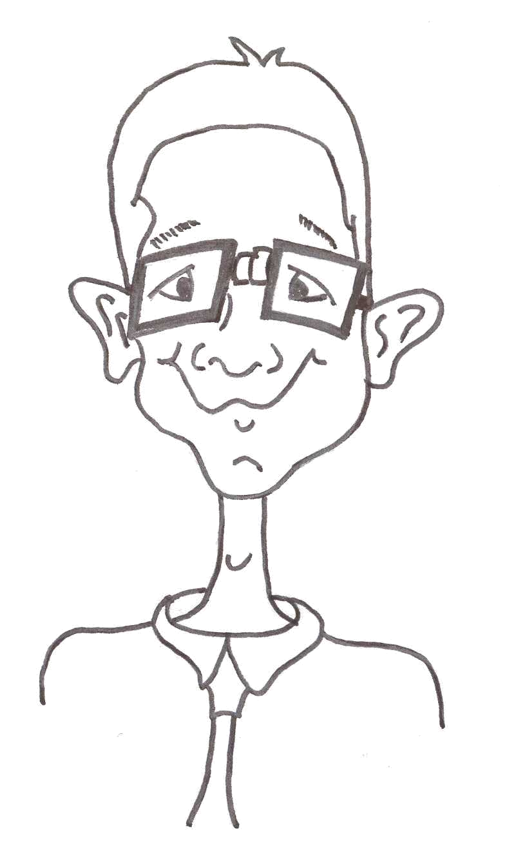

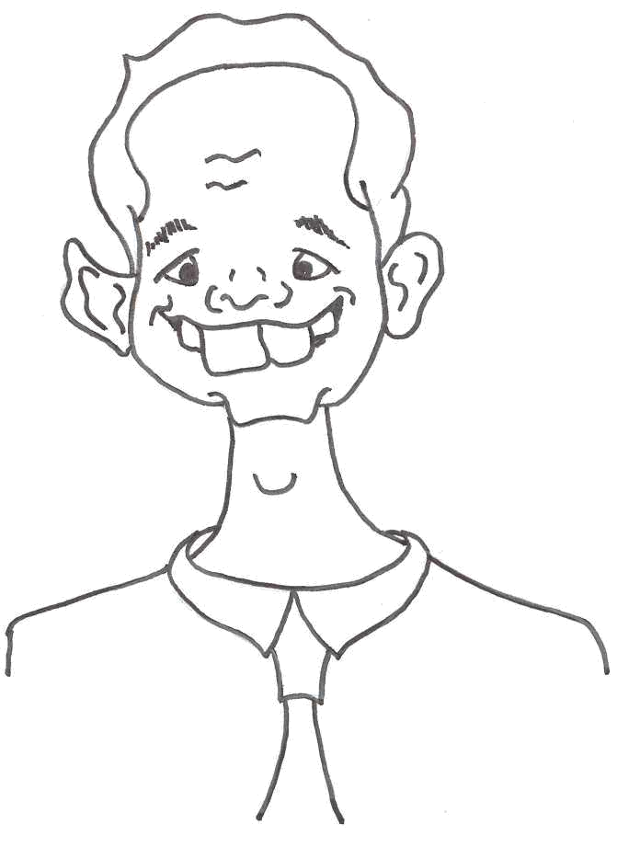

You are now going to be blood detectives to help Miss Taken try to solve the crime.


- How could you find out if any of the stains were blood?
- If a stain was blood, how might testing the blood to find its blood type help to catch the culprit?
- Whose blood will you need to test?
- How can you tell if blood has coagulated?
- What other information might blood give us?

Now write down some of the ideas you have discussed in your group.
Some ideas you may have discussed are –

- The stains may not be blood. Which substances might look like blood?

- A positive test for blood may not be able to tell the difference between animal and human blood

- What if there is more than one bloodstain?

- How blood can be collected for comparison with that from the crime scene

- How can testing for blood type help to solve the crime

- Is there DNA in blood?

