

DNA profiling and
reforestation projects
- information sheet

The FAIROAK Project
The flora of northern Europe has changed dramatically during the last 10,000 years. As climatic conditions have become more temperate since the end of the last ice age, European flora suited to a temperate climate have been able to migrate northwards from refugia (areas where species have survived because local conditions are favourable) in southern Europe.
Oak species represent a major component of the European forest resource. They supply quality wood, stabilise forests and enhance biological richness in forest ecosystems. Despite the silvicultural (woodland culture) and economic importance of oaks, little was known of their genetic diversity. This hampered genetic improvement programmes, decisions about seed transfers and choice of provenances (sources) from plantations. The more the species is used to plant new woodlands and enrich existing forest currently in monoculture, the more information about genetic diversity will become important.
The FAIROAK project was set up in 1994 and aimed to create a map of the oak (Quercus petreae and Quercus robur) genetic resources available across Europe, based on a systematic sampling of oak populations across the continent. Working collaboratively, scientists from a large number of institutions across Europe monitored the chloroplast DNA (ct DNA) in 2673 populations (12714 trees) ranging from the Mediterranean in the south, to Scotland and Scandinavia in the north. Using DNA profiling techniques, (restriction and electrophoresis of ct DNA) they have been able to identify differences in the ct DNA of trees of the same species across Europe. By comparing the ct DNA of trees in different areas, they have worked out which trees share the same genotype.

Evolution and conservation relevance
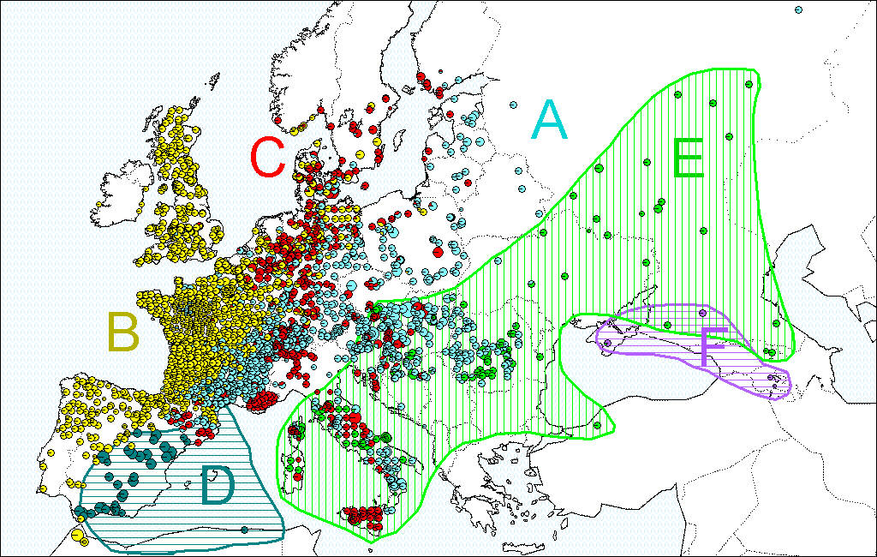
Geographically mapping the data in this way gives information on where genetic diversity is concentrated. This is solid, scientific information which forestry or environmental agencies can use as a basis for development of conservation policies. Six major lineages have been identified from the 12714 trees that were analysed. From Map 1, you will see that these six lines have quite separate geographical distributions along a longitudinal gradient and that the southern European regions (Iberian and Italian peninsula, Balkan regions) are clearly hot spots of diversity.
Map 1
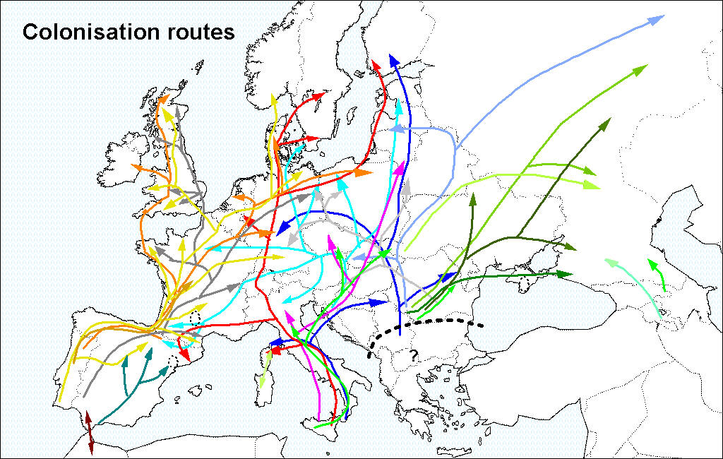
The map of geographical distribution of ct DNA variation was then compared to the map of fossil pollen deposits, in order to reconstruct the history of oak colonisation of Europe from the last ice age (postglacial recolonisation – see Map 2). Because oaks are carrier species (species which provide habitat for other organisms) in European forest ecosystems, the identification of their postglacial recolonisation routes is likely to provide useful information on the distribution and diversity of other plant and animal species. Furthermore, the patterns of recolonisation that were identified in the FAIROAK project can be considered as indicators of future migration movements of oaks as a result of climatic changes.
Map 2
The six lineages observed match the migration pathways that were followed by the oaks during postglacial recolonisation.

Technical and economic benefits
The synthetic maps that have been constructed in the FAIROAK project are based on populations of native origin. These results can be used to trace the geographical origin of trees within a forest and assist in their identification. It is now possible to identify autochthonous (native) trees from allocthonous (introduced) individuals of the same species. This information is highly valuable for ecological studies into oak decline and dieback, as sensitivity to disease may be greater in individuals that are not native to that particular area.
European regulations recommend that reforestation projects should use stock which is of local origin. Oak trees from northern provenances flush (burst their buds) later than more southern ones, making seed transfer between north and south risky. Knowing where different oak genotypes are native permits the genotyping of seed lots to check their origin. Further information about the FAIROAK project can be found at:
http://www.pierroton.inra.fr/Fairoak/
http://www.pierroton.inra.fr/Cytofor/Introduction.html

DNA profiling
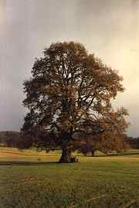
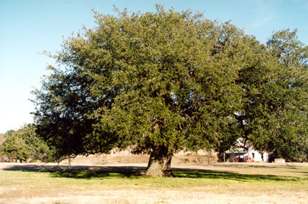
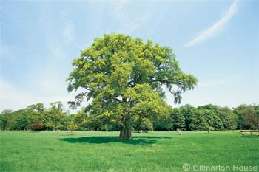
DNA profiling can be used to establish how closely different organisms are related. In this practical, you will use a simplified version of DNA profiling to determine which oak seed should be used in a reforestation project. Before starting the practical, you should be familiar with the structure of DNA, the use of restriction enzymes and the theory of gel electrophoresis. You will be given one sample of DNA from the seed from a local wood, and three samples of DNA from seeds of the same type of tree but which grow in different geographical areas. You should be able to make a recommendation on which seed to use by comparing the DNA profiles of the seeds.

