

DNA profiling
and biodiversity
- teacher/technical guide

Introduction
DNA profiling is used in a wide range of applications where knowledge of individual genotypes is beneficial. Its use in forensic science is the most commonly described purpose. This activity is set in the context of ecology/biodiversity and provides a set of four different scenarios, all based on real investigations and research, some of which was carried out at the Royal Botanic Garden, Edinburgh.
The scenarios are:
- DNA profiling and the conservation of British orchids: here, DNA profiling is used to determine whether a recently discovered British orchid is a new species.
- DNA profiling and reforestation projects: in this scenario, DNA profiling is used as the basis for selection of seed to be used in reforestation project.
- DNA profiling and Japanese knotweed: here, efforts are being made to discover more about the genetic make-up of Japanese knotweed with a view to finding effective control measures.
- DNA profiling and potato variety authentication: this scenario is based on an article from The Times of 8th May 2007, which describes concerns that foreign-grown potatoes are being sold as ‘British new potatoes’.
Through carrying out the technique of DNA profiling within these contexts and drawing conclusions from their results, students will develop greater awareness and understanding of:
- the use of DNA profiling in ecological applications
- genetic diversity and its importance
- some societal issues relating to biodiversity

The activity supports the various purposes of Curriculum for Excellence by offering students an opportunity to:
- learn individually and as part of a group
- use technology for learning
- evaluate environmental and scientific issues
- work in partnerships and teams

Using the activity
This activity could be used to support the learning and teaching of curriculum content relating to DNA, variation, ecology and biodiversity in Revised Higher Biology, Revised Higher Human Biology and Advanced Higher Biology.

Continued over

The support materials consist of:
- Four information sheets, for use by teachers and students:
  - DNA profiling and the conservation of British orchids
  - DNA profiling and reforestation projects
  - DNA profiling and Japanese knotweed
  - DNA profiling and potato variety authentication
- Student guide: this includes the practical protocol
- Teacher/technical guide: this includes guidance on the use of the activity
The protocols make use of the materials required for NCBE’s Nature’s Dice kit. The practical protocol for DNA profiling is common to all four scenarios. Only the DNA samples used differ. Three kinds of DNA samples (Mix1, Mix 2 and Mix 3) are supplied with the Nature’s Dice kit and are also available to purchase separately from it.
Requirements for the ‘DNA profiling and biodiversity. scenarios are given in the table below.
Item from NCBE | Cost (Dec 1st 2010)
Electrophoresis base unit (eight sets of low-voltage electrophoresis equipment and dispensing units) | £55.00
Nature’s Dice Module* [this will provide everything needed to run the protocols) | £ 115.00
Transformer 36 V | £40.00
Total cost | £195.00

* Each Nature’s Dice module contains enough material to run 8 scenarios (2 Orchid, 2 Reforestation, 2 Japanese Knotweed, 2 Potato). The remaining items in the kit could be used for subsequent DNA profiling practicals but the plasmids would have to be replenished [Plasmid mixture (3 tubes) costs £35.00]. Equipment provided with the base unit is reusable.
The full NCBE equipment and materials price list can be downloaded from http://www.ncbe.reading.ac.uk/NCBE/MATERIALS/PDF/NCBEpricelist.pdf
Before carrying out this practical, students should be familiar with the structure of DNA, the use of restriction enzymes, the theory of gel electrophoresis and its use in DNA profiling. We suggest that students work in groups of eight, sub-divided into pairs. Each pair within the group should be allocated a different scenario and carry out the related DNA profiling exercise.
Each scenario uses a different selection of these three kinds of DNA. These selections are described below for each scenario. In each scenario, students mix their DNA samples with the restriction enzyme BamH1, incubate the mixtures, prepare agarose gels for running the DNA, load, run and stain the gels, and observe and record the DNA profile. On completion of the practical, each pair should explain their scenario and results/ conclusions/ recommendations to others within the group.
Materials
Per individual or group (select DNA for the scenario being used)
6 tubes dried restriction enzyme BamH1 (blue tubes with separate caps)
2 microsyringes
Microsyringe tips - white
Marker pen
Disposal jar
Foam microtube rack
Materials (per individual or group) contd.
DNA samples (see information on scenarios below for further explanation)
- Orchid scenario: G1; G2; G3; N4; N5; N6
- Reforestation scenario: A1 (area to be reforested); A2; A3; A4; L (DNA ladder)
- Japanese knotweed scenario: K1; K2; K3; K4; G1; L (DNA ladder)
- Potato variety scenario: P1 (potato under test); P2; P3; P4; L (DNA ladder)
Loading dye (LD)
Agarose gel
Electrophoresis tank
Comb (6 well)
Carbon fibre electrodes
3 x 9 V batteries or NCBE 36 V transformer
Leads with crocodile clips
Stopwatch
To be shared
Water bath at 37°C
TBE electrophoresis buffer
Water
Azure A dye

Before the practical session – all scenarios
Dispense the samples appropriately for each scenario as shown in the tables below. Store the samples at -20°C until required.
Prepare the agarose gel by melting the agarose in TBE buffer. Before the lesson, melt the agarose and keep it molten at 50°C - 65°C (e.g. in a water bath) until it is required.
Use the 6-toothed comb for these scenarios. Each scenario requires one tank.
The Teacher’s Guide for the Nature’s Dice kit supplies excellent support information and guidance about the materials and general practical procedure. This guide is on the CD or memory stick that accompanies this course. It can also be downloaded from:
http://www.ncbe.reading.ac.uk/NCBE/PROTOCOLS/dice.html

Scenario : DNA profiling and the conservation of British orchids
In this scenario (see DNA profiling and the conservation of British orchids – information sheet), each DNA sample represents a different orchid DNA sample collected from mine spoil heaps in either Glasgow (G1 – 3) or Newcastle (N4 – 6).
DNA profiling and biodiversity
– rare orchids scenario
DNA Sample | Plant species | Area collected | DNA from Nature’s Dice kit | Location on Gel
G1 | E. helleborine | Glasgow | Mix 2 | Lane 1
G2 | E. youngiana | Glasgow | Mix 2 | Lane 2
G3 | E. youngiana | Glasgow | Mix 2 | Lane 3
N4 | E. helleborine | Newcastle | Mix 3 | Lane 4
N5 | E. youngiana | Newcastle | Mix 3 | Lane 5
N6 | E. youngiana | Newcastle | Mix 3 | Lane 6

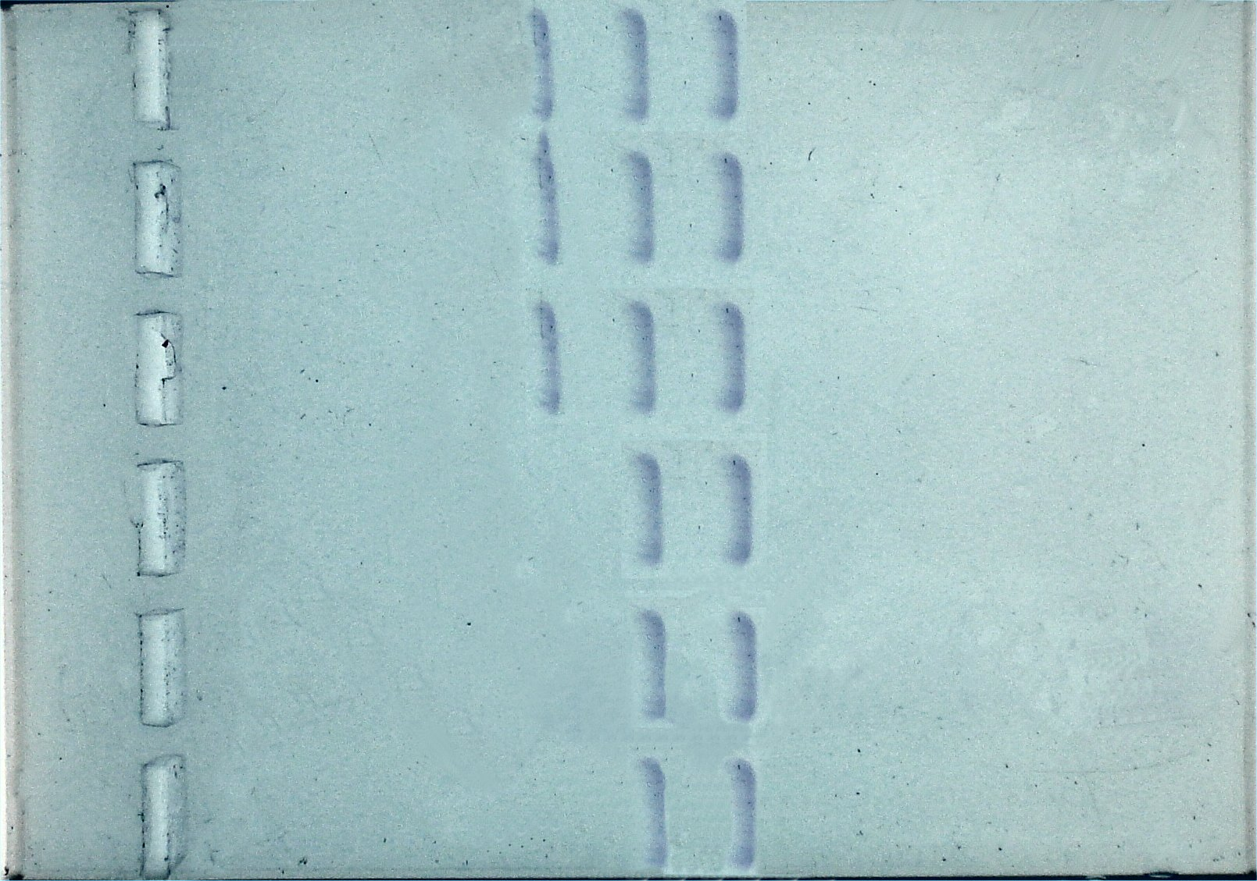
Results
1
2
3
4
5
6

DNA samples G1, G2 and G3 all show a similar profile, as do DNA samples N4, N5 and N6 although the profile for the latter three differs from the profile of the former. This suggests that whilst the E. youngiana looks different from E. helleborine they share a similar genetic background. Therefore E. youngiana is actually a variant of E. helleborine rather than a distinct species in itself.
The profile of DNA samples G1, G2 and G3 differs from the profile of samples N4, N5 and N6 because the organisms are geographically distant and mutation has occurred. The Newcastle population demonstrates a slightly different profile to the Glasgow population. The Glasgow and Newcastle populations of orchids have becoming genetically distinct due to the separation by distance.
Scenario : DNA profiling and reforestation projects
In this scenario (see DNA profiling and reforestation projects – information sheet), each DNA sample represents DNA collected from seeds of the same species from different areas. The DNA ladder is also used.
Note: only five lanes of the gel tank are used in this scenario.

DNA profiling and biodiversity
– Reforestation projects scenario
DNA Sample | Seed type | Area collected | DNA from Nature’s Dice kit | Location on gel
A1 | Quercus petreae | 1 | Mix 1 | Lane 1
A2 | Quercus petreae | 2 | Mix 3 | Lane 2
A3 | Quercus petreae | 3 | Mix 1 | Lane 3
A4 | Quercus petreae | 4 | Mix 2 | Lane 4
L |  |  | Ladder | Lane 5

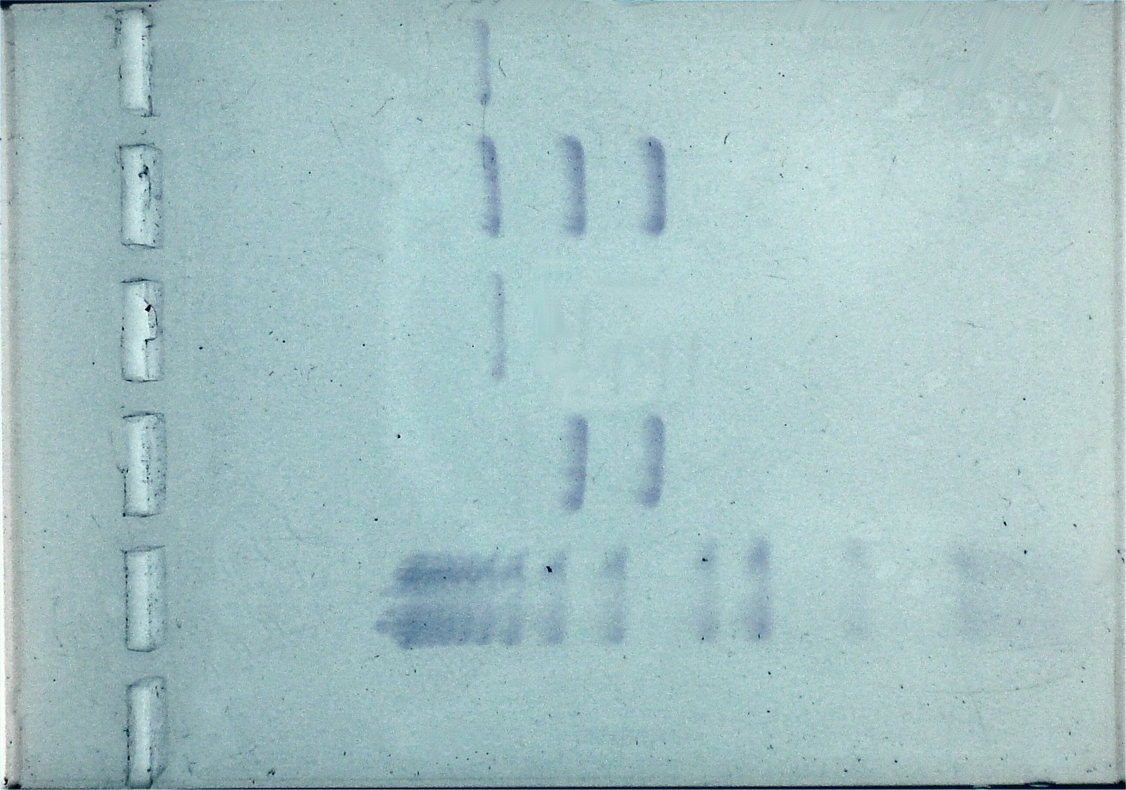
Results
6
5
4
3
2
1

DNA sample A1 represents DNA taken from seed from the wood that is to be replanted and for which a best match is being sought. The DNA profile of A1 matches that of A3. Students should recommend, therefore, that seed from Area 3 be used in the reforestation of Area 1.
Although from the same species, genetic profiles of seeds taken from areas 2, 3 and 4 differ from each other. This is due to geographical distance, mutation and natural selection.

Scenario : DNA profiling and Japanese knotweed
In this scenario (see DNA profiling and Japanese knotweed – information sheet), the DNA samples represent DNA collected from Japanese knotweed plants from different areas of the British Isles and an example of giant knotweed. The DNA ladder is also used.

DNA profiling and biodiversity
– Japanese knotweed scenario
DNA Sample | Plant species | Area collected | DNA from Nature’s Dice kit | Location on Gel
K1 | Japanese knotweed | 1 - Scotland | Mix 3 | Lane 1
K2 | Japanese knotweed | 2 - Ireland | Mix 3 | Lane 2
K3 | Japanese knotweed | 3 - Wales | Mix 3 | Lane 3
K4 | Japanese knotweed | 4 - England | Mix 3 | Lane 4
G1 | Giant knotweed |  | Mix 2 | Lane 5
L |  |  | Ladder | Lane 6

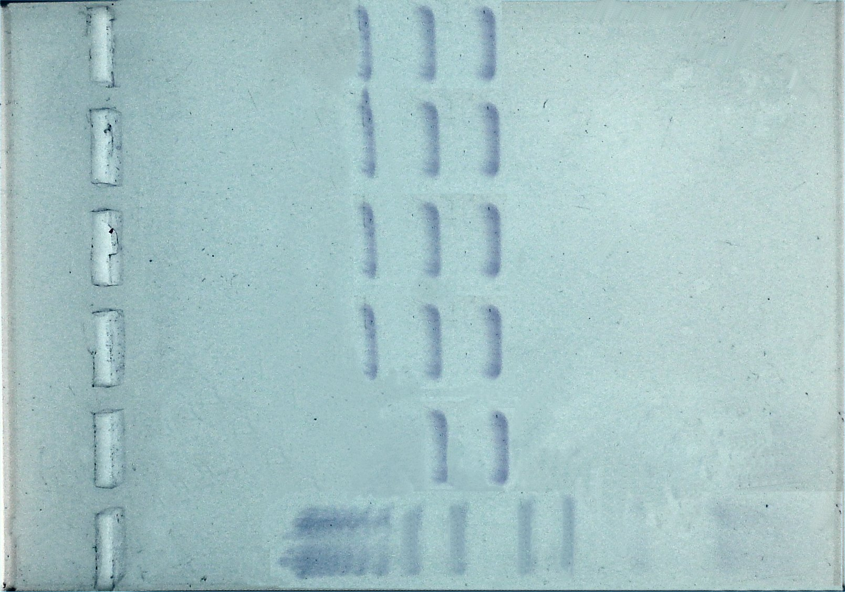
Results
6
5
4
3
2
1

DNA samples K1 – K4 represent DNA taken from Japanese knotweed plants from different parts of the British Isles, DNA sample G1 represents DNA taken from a Giant knotweed plant. The DNA profiles of each of the Japanese knotweeds are identical, indicating that they are clones. Students may suggest that Japanese knotweed found across the British Isles is monoclonal. Students should be encouraged to consider that, although they have profiled samples of Japanese knotweed from across the British Isles, their sample number is low and to suggest that examination of profiles from a greater number of plants should be undertaken.
They might also reflect on the implication of this widespread nuisance being descended from one original plant introduced into the British Isles in the 1800s! The sample from Giant knotweed is included simply to provide a different profile and to indicate that different species demonstrate different DNA profiles.

Scenario : DNA profiling and potato variety authentication
In this scenario (see DNA profiling and potato variety identification – information sheet), each DNA sample represents DNA collected from different varieties of potatoes. The DNA ladder is also used.

Note: only five lanes of the gel tank are used in this scenario.

DNA profiling and biodiversity
– Potato variety authentication scenario
DNA Sample | Potato type | Area collected | DNA from Nature’s Dice kit | Location on gel
P1 | ‘Suspect’ | 1 | Mix 3 | Lane 1
P2 | Pentland Dell | 2 | Mix 2 | Lane 2
P3 | Maris Piper | 3 | Mix 1 | Lane 3
P4 | Morene | 4 | Mix 3 | Lane 4
L |  |  | Ladder | Lane 5

Results
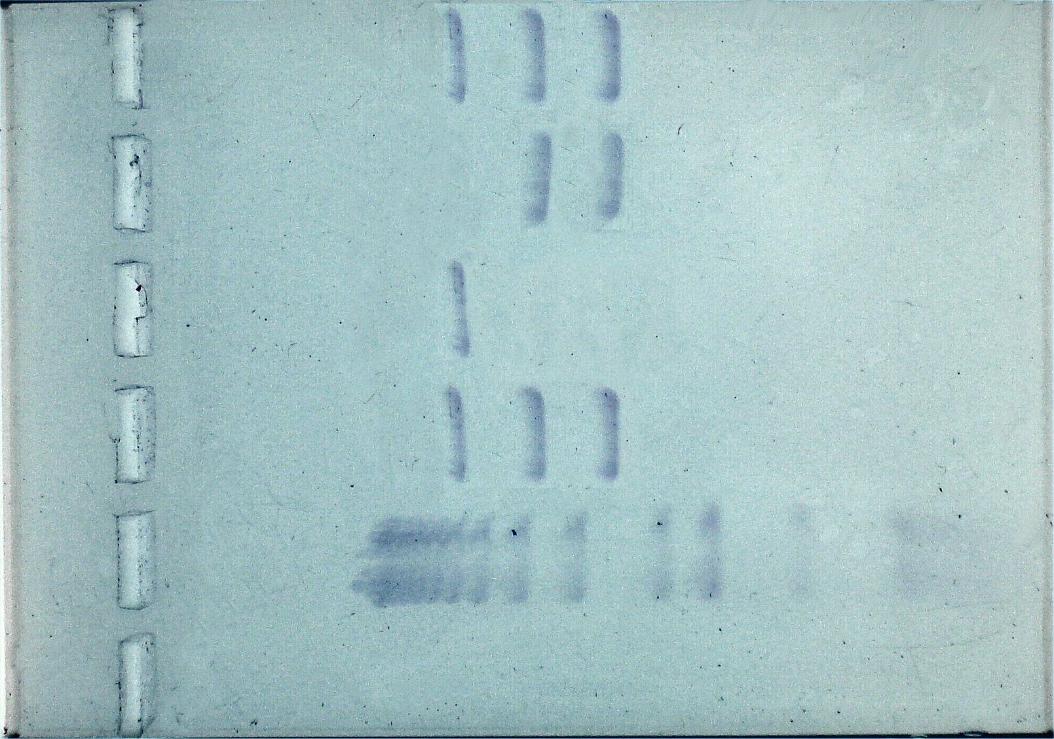

DNA sample P1 represents DNA taken from potatoes being marketed as British-grown Maris Pipers and whose labelling/authenticity is being questioned. The DNA profile of P1 matches that of P4. Students should come to the conclusion, therefore that the potatoes are labelled incorrectly.
Although from the same species, genetic profiles of the range of varieties differ from each other. This is due to mutation and selection of resulting traits by growers.

* * * * *
We are very grateful for the help provided to us in designing these scenarios by Dr Michelle Hollingsworth, Dr Pete Hollingsworth and Dr Mark Hughes of the Royal Botanic Garden, Edinburgh.

