

DNA profiling and
Japanese knotweed
- information sheet

The history of Japanese knotweed in the British Isles
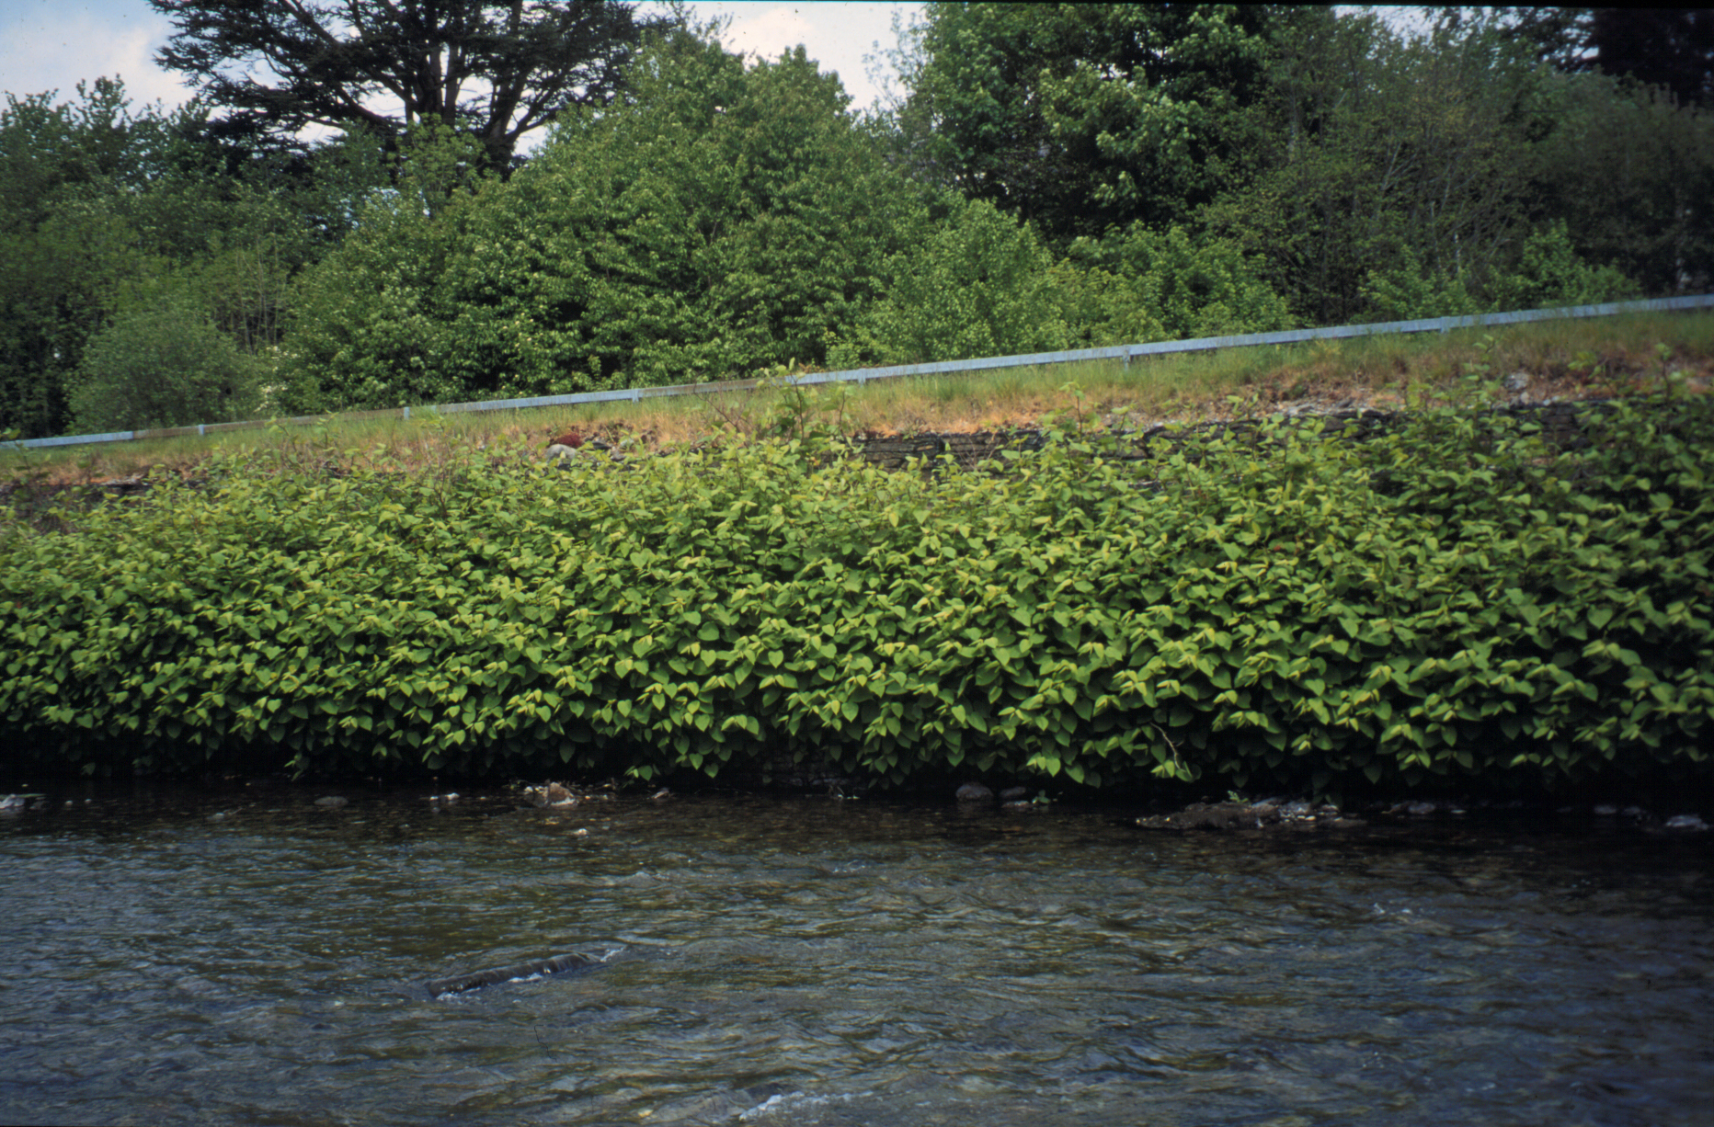
Japanese knotweed (Fallopia japonica syn. Polyganum cuspidatum) is a plant native to Japan, Taiwan and Northern China. It was introduced into the UK in the 1800s for use as an ornamental garden plant. Japanese knotweed is now widespread throughout the British Isles. It is found growing in profusion along railway lines, canal and river banks, roads and footpaths, in cemeteries, on derelict sites or anywhere that it has been dumped, dropped or deposited. The speed with which it has spread across the country is spectacular considering that Japanese knotweed does not produce seeds.
Japanese Knotweed
Photo courtesy of Michelle Hollingsworth
Japanese knotweed is now categorised as an invasive, non-native species. Under provisions made in the Wildlife and Countryside Act 1981, it is an offence to cause Japanese knotweed to grow in the wild. Under the Environmental Protection Act, 1990, Japanese knotweed is classed as ‘controlled waste’. As ‘controlled waste’, it should not be included with normal household waste but must be disposed of at licensed landfill sites. For further information, see:
http://www.netregs.gov.uk/netregs/processes/367836/?version=1&lang=_e
Why is Japanese knotweed a problem?
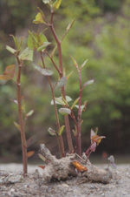
When established, Japanese knotweed aggressively over-runs native plants and its growth in urban areas has brought about and continues to cause significant damage. Its shoots are able to push through asphalt and damage pavements, roads, car parks etc. In addition, Japanese knotweed can grow to up to three metres in height, causing visibility problems on roadsides and shading out native plants by producing a dense canopy of leaves early in the growing season. Although it is not toxic to humans, animals or other plants, it offers a poor habitat for native insects, birds and mammals so reducing biodiversity in any area it colonises. Once this plant has become established, it is extremely difficult to eradicate and hundreds of thousands of pounds are spent each year on the control of Japanese knotweed.
Japanese Knotweed growing through a pavement.
Photo courtesy of Environment and Heritage Service, Cornwall.

Japanese knotweed can grow as much as 2 cm per day and will grow on any type of soil, no matter how poor. Each stand of Japanese knotweed is supported by a widespread, vigorous underground root (rhizome) system that can extend several metres around and beneath the aerial part of the plant depending on ground conditions. Although it does not produce seeds, Japanese knotweed can regenerate and form a new plant from a tiny section of root (as little as 0.8 g). This capability is thought to explain how Japanese knotweed has grown to be such a problematic, invasive weed as such root fragments are easily dispersed by water, people, construction traffic etc.
What can be done to help solve the problem of Japanese knotweed?
Options for the control of Japanese knotweed include cultural control (digging out) and chemical control (using herbicides and weedkillers). These control methods take a number of years to be effective and come with their own associated problems such as how to dispose of the waste.
In an attempt to find out more about the plant, Dr Michelle Hollingsworth from the Royal Botanic Garden Edinburgh, has been researching genetic diversity in Japanese knotweed. In the British Isles, Japanese knotweed reproduces only by means of asexual reproduction. Variation within a species is maintained and extended by sexual reproduction. The ability to reproduce by asexual (vegetative) reproduction alone will have major impact on the genetic diversity within a population. Dr Hollingsworth has been using DNA profiling techniques to investigate the genetic makeup of Japanese knotweed plants that inhabit different parts of the British Isles. She has been trying to find out whether Japanese knotweed in the British Isles is multiclonal or monoclonal. If multiclonal, different populations of Japanese knotweed would demonstrate genetic differences that would result in different banding patterns in their DNA profiles; if monoclonal, plants from different populations would have the same genetic make-up and DNA profiles would be identical. All organisms within a single population that has been produced through vegetative reproduction will display identical DNA profiles.
Additional information about this research into Japanese knotweed can be found on p 10 of the Leicester University Bulletin, May 1999. The Bulletin can be downloaded from: www.le.ac.uk/bulletin
DNA profiling
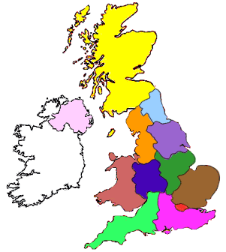
DNA profiling can be used to establish whether different organisms are related. In some cases, the results of a DNA profile can be used to gain information about the closeness of relationships.
1
2
3
4
In this practical, you will use a simplified version of the technique of DNA profiling to investigate the genetic relationship of different Japanese knotweed plants to each other and to Giant knotweed, a related plant. Before starting the practical, you should ensure that you are familiar with the structure of DNA, the use of restriction enzymes and the theory of gel electrophoresis. You will be provided with four samples of DNA (K1 – K4) taken from Japanese knotweed plants found growing in the areas shown in the map and a DNA sample from Giant knotweed (G1).

